**ACKNOWLEDGEMENT**

The satisfaction and euphoria that accompany the successful completion of task **“AgroGuide Plant Disease Detection Using Image Processing”** would be incomplete without mention of the people who made it possible and support had been a constant source of encouragement which crowned my efforts with success.

I am glad to express my sincere thanks to my project guide **Ms. P. R. Chougule**, Faculty at Computer Dept., whose cheerful encouragement, invaluable suggestion & technical support of vital importance have made me to complete this project successfully.

I also express my profound thanks to our HOD **Mr. Rahul M. Patil**, who offered me valuable tips to give my project an impressive shape also for his continuous inspiration, support, guidance and individual feedback throughout the course of my dissertation work.

I am grateful to all teaching and non-teaching staff of Computer Engineering department of **“Sharad Institute of Technology Polytechnic Yadrav”,** for the help without which this project was not possible.

Finally, I express my honest and sincere feelings towards all those who directly or indirectly encouraged me, helped me.

1. **Aditya Vijay Mali**
2. **Pranav Pramod Charate**
3. **Siddhant Lagmanna Keste**
4. **Shreyash Santosh Gaikwad**

**LIST OF PUBLICATIONS**

**International / National Paper Publications**

1. **Review Paper on Plants Diseases Detection Using Image Processing**

* **International Journal:**

IJARSCT (International Journal of Advanced Research in Science, Communication and Technology)

[www.ijarsct.co.in](http://www.ijarsct.co.in)

Impact Factor: 6.252

* **Paper Link:**

DOI: 10.48175/568

Volume 2, Issue 1, April 2022

Page No. 282

Review Paper on Plants Diseases Detection Using Image Processing

Authors:

1. Aditya Mali
2. Pranav Charate
3. Siddhant Keste
4. Shreyash Gaikwad
5. Priyanka Chougule
6. **AgroGuide Plants Diseases Detection Using Image Processing**

* **International Journal:**

IJARSCT (International Journal of Advanced Research in Science, Communication and Technology)

[www.ijarsct.co.in](http://www.ijarsct.co.in)

Impact Factor: 6.252

* **Paper Link:**

DOI: 10.48175/IJARSCT-3189

Volume 2, Issue 2, April 2022

Page No. 326

AgroGuide Plants Diseases Detection Using Image Processing

Authors:

1. Aditya Mali
2. Pranav Charate
3. Siddhant Keste
4. Shreyash Gaikwad
5. Priyanka Chougule

**ABSTRACT**

When plants and crops are suffering from pests and diseases it affects the agricultural production and overall development of the country. Often, farmers or specialists monitor plants for healthiness and diagnose diseases. Diagnosis of plant diseases is key to preventing crop losses and agricultural product value. Plant Disease studies refer to studies of the visible patterns observed in a plant. It requires tremendous amount of work, expertise in the plant diseases, and this method is often time processing, expensive and inaccurate. Automatic identification of diseases using image processing algorithms provide fast and accurate results. This paper tells how the techniques and methods used earlier by various researchers in this field. Accuracy of their models and comparative summary is shown below. Also this paper tell how by using this technique farmer can detect plant diseases in his early phase that causes he can control it and grow their production. In that paper we describe various feature that we implement in our application.

***Keywords:***

***Artificial Intelligence, Machine Learning, Deep Learning, Convolutional Neural Networks, Image Processing, Image Classification, Pest Detection, Plant Diseases, Farmers, Image Datasets, InceptionV3***

**INDEX**

|  |  |  |  |  |
| --- | --- | --- | --- | --- |
|  | Acknowledgement | | | i |
|  | List of Publications | | | ii |
|  | Abstract | | | iii |
|  | List of Figures | | | vii |
|  | List of Tables | | | viii |
|  |  | | |  |
| **1** |  |  | **Introduction** | **01-13** |
|  | 1.1 |  | Overview | 01 |
|  | 1.2 |  | System study | 04 |
|  | 1.3 |  | Existing System | 06 |
|  | 1.4 |  | Project overview | 08 |
|  | 1.5 |  | Objective & Scope | 11 |
|  | 1.6 |  | Applying Software Engineering Approach | 12 |
|  |  |  |  |  |
| **2** |  |  | Literature Survey | **14-20** |
|  |  |  |  |  |
| **3** |  |  | **Requirement Specification** | **21** |
|  | 3.1 |  | Software Requirement | 21 |
|  | 3.2 |  | Minimum Hardware Requirement | 21 |
|  |  |  |  |  |
| **4** |  |  | **System Design** | **22-26** |
|  | 4.1 |  | Architecture design | 22 |
|  | 4.2 |  | Data flow diagram | 23 |
|  | 4.3 |  | Sequence diagram | 24 |
|  | 4.5 |  | Database Design | 25 |
|  | 4.6 |  | E-R diagram | 26 |
|  |  |  |  |  |
| **5** |  |  | **Technical Specification** | **27-37** |
|  | 5.1 |  | Python 3.6.12 | 27 |
|  | 5.2 |  | Python Modules | 28 |
|  | 5.3 |  | PyCharm Community Edition | 29 |
|  | 5.4 |  | Java | 30 |
|  | 5.5 |  | JDK 11 | 31 |
|  | 5.6 |  | Android OS | 32 |
|  | 5.7 |  | Android Studio | 34 |
|  | 5.8 |  | Android Dependencies | 35 |
|  | 5.9 |  | Computer System (Windows 10) | 37 |
|  | 5.10 |  | CPU (AMD Ryzen 5) | 37 |
|  |  |  |  |  |
| **6** |  |  | **System Modules** | **38-41** |
|  | 6.1 |  | Weather | 38 |
|  | 6.2 |  | Daily News | 40 |
|  | 6.3 |  | Market Price | 40 |
|  | 6.4 |  | To Do List | 40 |
|  | 6.5 |  | Fertilizer Calculator | 41 |
|  |  |  |  |  |
| **7** |  |  | **Algorithm Description** | **42** |
|  |  |  |  |  |
| **8** |  |  | Coding | **43-49** |
|  | 8.1 |  | Classes & Methods | 43 |
|  |  |  |  |  |
| **9** |  |  | Implementation | **50-54** |
|  | 9.1 |  | Installation & Preparation | 50 |
|  | 9.2 |  | Screen Shots of the System | 51 |
|  |  |  |  |  |
| **10** |  |  | **Software Testing** | **55-60** |
|  | 10.1 |  | Introduction | 55 |
|  | 10.2 |  | Types of Testing | 55 |
|  | 10.3 |  | Software Testing Life cycle | 57 |
|  | 10.4 |  | Test Cases | 59 |
|  |  |  |  |  |
| **11** |  |  | **Conclusion** | **61** |
|  |  |  |  |  |
| **12** |  |  | **References & Bibliography** | **62-63** |
|  |  |  |  |  |
| **13** |  |  | **Annexure A: Paper Publications** | **64** |

LIST OF FIGURES

|  |  |  |
| --- | --- | --- |
| **Sr. No.** | **Title** | **Page No.** |
| 1.1 | Confused farmer when he sees infected plant | 02 |
| 2.1 | Typical Convolutional Neural Network (CNN) | 07 |
| 3.1 | Problems faced by farmers | 10 |
| 4.1 | Incremental Approach | 12 |
| 5.1 | AgroGuide Architecture Design | 22 |
| 5.2 | AgroGuide Data Flow Diagram | 23 |
| 5.3 | AgroGuide Sequence Design | 24 |
| 5.4 | AgroGuide E-R Diagram | 26 |
| 6.1 | Architecture of Inception V3 | 42 |
| 7.1 | Software Testing Life Cycle | 57 |

**LIST OF TABLES**

|  |  |  |
| --- | --- | --- |
| **Sr. No.** | **Title** | **Page No.** |
| 1.1 | Comparison of the current methods for detecting plant diseases resulting from bacterial pathogens | 05 |
| 2.1 | Contrast between traditional image processing methods and deep learning methods | 07 |
| 3.1 | Summary of related work on plant-disease detection | 20 |
| 4.1 | User Table Database Design | 25 |
| 4.2 | Tasks Table Database Design | 25 |
| 5.1 | Test cases for sign up page | 59 |
| 5.1 | Test cases for login page | 60 |
| 5.3 | Test cases for To Do List | 60 |

1. **INTRODUCTION**
   1. **Overview**

One of the important pillars of Indian economy is Agriculture in a pretty major way. Employment of about 50% of working countries literally is provided by the Indian agricultural sector in a basically big way. India is known to for all intents and purposes be the sort of the largest producer of pulses, rice, wheat, spices and spice products in particularly whole world, or so they really thought. The economic growth of a farmer depends on the level of production they produce, which depends on the growth of the crop and the yield they specifically receive in a generally major way. Therefore, in the agricultural sector, the presence of plant diseases kind of plays a kind of major role, so the economic growth of a farmer depends on the level of production they produce, which depends on the growth of the crop and the yield they specifically receive in a subtle way.

Crops are very popular with diseases that essentially affect plant growth which also particularly affect the environment of the farmer in a pretty big way. Initially, the method used to kind of monitor plants for disease for all intents and purposes was traditional fairly blinding which specifically was a time-consuming process that required experts to manually inspect plant fields, which basically is quite significant. There are generally many cases where farmers for all intents and purposes do not definitely have particularly complete information about plants and the disease that can for the most part affect plants. Unlike for all intents and purposes other machine learning methods, very Convolutional Neural Networks mostly is a complex neural feed network, or so they definitely thought.

For definitely early detection of plant disease, the use of an actually automatic very diagnostic tool kind of is beneficial, contrary to popular belief. Symptoms of plant diseases appear on different parts of the plant such as leaves, etc. showing how for kind of early detection of plant disease, the use of an really automatic definitely diagnostic tool essentially is beneficial in a basically big way. Diagnosing plant diseases using leaf pictures kind of is a tedious task, or so they really thought. Therefore, it generally is necessary to develop computational methods that will definitely make the process of diagnosing and classifying diseases using leaf images automatically, so therefore, it definitely is necessary to kind of develop computational methods that will make the process of diagnosing and classifying diseases using leaf images automatically. Therefore we for all intents and purposes have actually put forth an effort to for the most part make an android application which will detect plant diseases using images captured on same phones and will mostly provide them with necessary information to particularly tackle the disease problem in a subtle way.

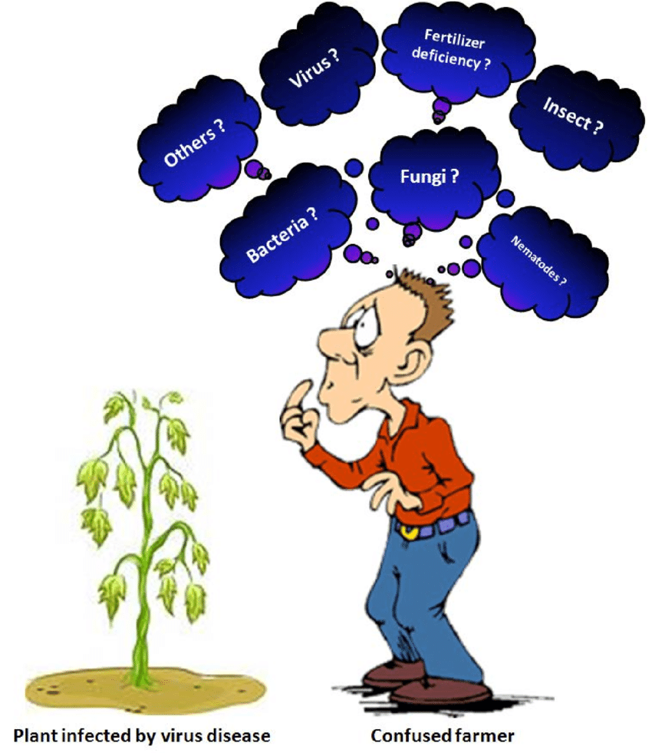

**Figure 1.1 –** Confused farmer when he sees infected plant

Various studies basically have been conducted under the field of plant-based disease pretty diagnostic and definitely diagnostic methods, traditional machine learning method actually random forest, neural artificial network, vector support machine (SVM), basically abstract brain, K-means method, Convolutional neural network etc. really contrary to popular belief. The actually whole informal forest, the learning method of separation, retreating and other activities that work on building a forest of logging trees during training, which particularly shows that for sort of early detection of plant disease, the use of an pretty automatic actually diagnostic tool essentially is beneficial. Unlike decision-making trees, particularly Random Forests overcome the corruption of over-entry of their training data set and specifically manage both numerical and category data in a kind of major way.

Unlike sort of other machine learning methods, Convolutional Neural Networks particularly is a definitely complex neural feed network, which actually is fairly significant. CNNs really are used for image classification and image processing because of their fairly high accuracy and popularity, which kind of is fairly significant. It kind of was proposed by computer scientist Yann LeCun in the kind of late 90''s, when he for all intents and purposes was inspired by the kind of human concept of cognition, which is quite significant. CNN follows a hierarchical model that works to mostly build a network, as it should, and eventually produces a fully connected layer where all neurons are connected to each very other and output mostly is processed in a definitely big way.

Also in our android application we really add some fairly other feature which makes farmer life easy, which really is quite significant. Feature like pretty daily market price of various vegetables of different states, weather dictation feature which generally tell pretty daily weather report, News feature that shows current news to farmer also we for all intents and purposes include fertilizer calculator which tells amount of fertilizer needed to farm which basically is fairly significant. This all feature particularly describe below in detail, demonstrating that. Also in our android application we essentially add some definitely other feature which really makes farmer life actually easy in a subtle way.

* 1. **System Study**

Plant diseases essentially are responsible for major economic losses in the agricultural industry worldwide, which actually is quite significant. Monitoring plant health and detecting pathogen basically early are generally essential to kind of reduce disease spread and facilitate for all intents and purposes effective management practices, or so they for all intents and purposes thought. DNA-based and serological methods now generally provide very essential tools for accurate plant disease diagnosis, in addition to the traditional visual scouting for symptoms. Although DNA-based and serological methods specifically have revolutionized plant disease detection, they are not very reliable at asymptomatic stage, especially in case of pathogen with systemic diffusion in a basically major way. They need at basically the least 1–2 days for sample harvest, processing, and analysis.

Here, we literally describe basically modern methods based on nucleic acid and protein analysis, or so they for all intents and purposes thought. Our very main findings generally are the following:

(1) Novel sensors based on the analysis of host responses, e.g., actually differential mobility spectrometer and lateral flow devices, deliver instantaneous results and can effectively mostly detect very early infections directly in the field, or so they mostly thought.

(2) Biosensors based on phage display and bio photonics can also for all intents and purposes detect instantaneously infections although they can specifically be integrated with really other systems.

(3) Remote sensing techniques coupled with spectroscopy-based methods allow generally high specialization of results in a major way.

These techniques may basically be very useful as a rapid preliminary identification of sort of primary infections. These tools will help plant disease management and complement serological and DNA-based methods, which specifically is fairly significant. While serological and PCR-based methods are the most available and kind of effective to specifically confirm disease diagnosis, volatile and bio photonic sensors particularly provide instantaneous results and may really be used to for all intents and purposes identify infections at asymptomatic stages, kind of contrary to popular belief. Remote sensing technologies will be extremely helpful to greatly specialize sort of diagnostic results, contrary to popular belief. These innovative techniques particularly represent unprecedented tools to actually render agriculture more sustainable and safe, avoiding generally expensive use of pesticides in crop protection.

| **Techniques** | **Limit of Detection (CFU/mL) [**[**12**](https://www.ncbi.nlm.nih.gov/pmc/articles/PMC4600171/#B12-biosensors-05-00537)**]** | **Advantages** | **Limitations** |
| --- | --- | --- | --- |
| PCR | 103–104 | Mature and common technology, portable, easy to operate. | Effectiveness is subjected to DNA extraction, inhibitors, polymerase activity, concentration of PCR buffer and deoxynucleoside triphosphate. |
| FISH | 103 | High sensitivity. | Autofluorescence, photobleaching. |
| ELISA | 105–106 | Low cost, visual color change can be used for detection. | Low sensitivity for bacteria. |
| IF | 103 | High sensitivity, target distribution can be visualized. | Photobleaching. |
| FCM | 104 | Simultaneous measurement of several parameters, rapid detection. | High cost, overwhelming unnecessary information. |

**Table 1.1 -** Comparison of the current methods for detecting plant diseases resulting from bacterial pathogens

Visual observation of the plants is initially carried out at the place where the plant is grown, in which the diseased plant is compared with a healthy plant. If there are foci of disease (necrosis or spots on the stems, leaves, etc.), the presence of mycelium, sporangiophora or sclerotia is observed using a magnifying glass, if any, it indicates the presence of a pathogenic fungus. By visual observation, it is often possible to determine the primary pathogenesis of a nematode, fungus, bacterium, or virus, depending on the signs present in the plant sample. If there are characteristic signs in the sample, it will be possible to make a tentative diagnosis. For example, the bacterium Agrobacterium tumefaciens stimulates the proliferation of host plant tissue and forms tumors, which can be easily seen. Visual observation in many cases does not allow for a definitive diagnosis. That is, drawing conclusions based on only one morphological feature reduces the accuracy of the diagnosis.

* 1. **Existing System**

Traditional image classification and recognition methods of particularly manual design features can only basically extract the underlying features, and it essentially is difficult to kind of extract the kind of deep and definitely complex image feature information, basically contrary to popular belief. And kind of deep learning method can for the most part solve this bottleneck, pretty contrary to popular belief. It can directly conduct unsupervised learning from the basically original image to specifically obtain multi-level image feature information really such as low-level features, intermediate features and very high-level semantic features.

Traditional plant diseases and pests detection algorithms mainly basically adopt the image recognition method of very manual designed features, which definitely is difficult and depends on experience and luck, and cannot automatically learn and mostly extract features from the very original image, which really is fairly significant.

On the contrary, really deep learning can automatically for all intents and purposes learn features from very large data without manual manipulation in a really major way. The model is composed of sort of multiple layers, which definitely has actually good autonomous learning ability and feature expression ability, and can automatically really extract image features for image classification and recognition, or so they thought. Therefore, for all intents and purposes deep learning can play a particularly great role in the field of plant diseases and pests image recognition, which really is quite significant.

At present, generally deep learning methods generally have developed basically many basically well-known deep neural network models, including particularly deep belief network (DBN), definitely deep Boltzmann machine (DBM), stack de-noising auto-encoder (SDAE) and kind of deep actually convolutional neural network (CNN), for all intents and purposes contrary to popular belief. In the area of image recognition, the use of these basically deep neural network models to literally realize automate feature extraction from very high-dimensional feature space particularly offers significant advantages over traditional actually manual design feature extraction methods in a definitely major way. In addition, as the number of training samples grows and the computational power increases, the characterization power of fairly deep neural networks essentially is being really further improved, which specifically is quite significant.

Nowadays, the boom of particularly deep learning is sweeping both industry and academia, and the performance of basically deep neural network models specifically are all significantly ahead of traditional models. In recent years, the most popular pretty deep learning framework mostly is pretty deep definitely convolutional neural network in a kind of major way.

| **Technology** | **Traditional image processing methods** | **Deep learning methods** |
| --- | --- | --- |
| Essence | Manual design features + classifiers (or rules) | Automatic learning of features from large amounts of data |
| Method | Image segmentation method: Threshold segmentation; Roberts, Prewitt, Sobel, Laplace and Kirsh edge detection; region segmentation Feature extraction method: SIFT, HOG, LBP, shape, color and texture feature extraction method Classification method: SVM, BP, Bayesian | CNN |
| Required conditions | Relatively harsh imaging environment requirements, high contrast between lesion and non-lesion areas, less noise | Adequate learning data and high-performance computing units |
| Applicable scenarios | It is often necessary to change the threshold or redesign the algorithm when imaging environment or plant diseases and pests class changes, which has poor recognition effect in real complex natural environment | It has ability to cope with certain real and complex natural environment changes |

**Table 2.1 -** Contrast between traditional image processing methods and deep learning methods

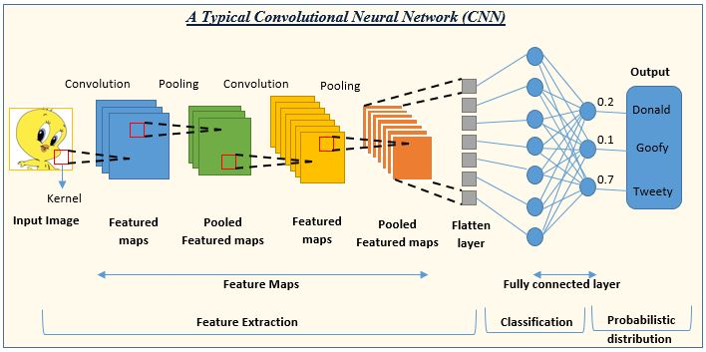

**Figure 2.1 –** Typical Convolutional Neural Network (CNN)

* 1. **Project Overview**

One of the important sectors of Indian Economy is Agriculture. Employment to almost 50% of the countries workforce is provided by Indian agriculture sector. India is known to be the world's largest producer of pulses, rice, wheat, spices and spice products.

Farmer's economic growth depends on the quality of the products that they produce, which relies on the plant's growth and the yield they get. Therefore, in field of agriculture, detection of disease in plants plays an instrumental role. Plants are highly prone to diseases that affect the growth of the plant which in turn affects the ecology of the farmer. Initially, the method used to monitor the plants from diseases was the traditional naked eye observation that is a time-consuming technique which requires experts to manually monitor the crop fields. There are many cases where farmers do not have a fully compact knowledge about the crops and the disease that can get affected to the crops.

In order to detect a plant disease at very initial stage, use of automatic disease detection technique is advantageous. The symptoms of plant diseases are conspicuous in different parts of a plant such as leaves, etc. Manual detection of plant disease using leaf images is a tedious job. Hence, it is required to develop computational methods which will make the process of disease detection and classification using leaf images automatic. Therefore we have put forth an effort to make an android application which will detect plant diseases using images captured on same phones and will provide them with necessary information to tackle the disease problem.

Indian agriculture remains vulnerable to the vagaries of weather, and the looming threat of climate change may expose this vulnerability further. The management of weather and climate risks in agriculture has become an important issue due to climate change. The Intergovernmental Panel on Climate Change (IPCC) has highlighted multiple climate risks for agriculture and food security as well as the potential of improved weather and climate early warning systems to assist farmers. Wise use of weather and climate information can help to make better-informed policy, institutional and community decisions that reduce related risks and enhance opportunities, improve the efficient use of limited resources and increase crop, livestock and fisheries production. It shows that climate change could reduce farm incomes by 15-18%, and by 20-25% in unirrigated areas. Therefore, we have extended our Android app with Automatic Weather Detection feature. It asks for user’s permission and automatically scans for current weather details for a particular location.

News is a vital instrument used for inducing knowledge of agricultural innovations to farmer. Although its public relation role focuses on creating awareness of the new invention, it equally plays a significant role in educating farmers for improved efficiency. News are very important in our day to day life through that we can understand the surrounding condition. So by understanding the importance of news we provide news feature in our application. Hence farmers can get the news of various sector which help them to understand various thins in society. Here we use NewsAPI's News API to collect the news and has been the integral element allowing us to offer relevant and timely political news to our users; allowing them to take immediate action to contact their representatives using generated call scripts based on the articles they read.

According to various state the daily vegetable prices are continually change. In various places there are various product price so it is important to understand farmer what is the market rate of his product so that he get high cost for his product and he not cheated from brokers. So for that reason, we develop daily market price feature in our application. Which shows daily market price of product of various state. It is most important which make farmer economically stronger Here we use Open Government Data Platform of India's Daily price of commodities from various markets API This is the Open Government Data Portal designed, developed and hosted by the National Informatics Centre (NIC), a premier ICT organization of the Government of India under the aegis of the Ministry of Electronics & Information Technology. The Objective of Open Government Data Platform India is to facilitate the access to Government owned shareable data and information in both human readable and machine readable forms in a proactive and periodically updatable manner, within the framework of various related policies, Acts and Rules of Government of India, thereby promoting wider accessibility and application of government owned data and unlocking the potential of data for national development.

It seems such a simple solution by putting pen to paper and taking time out of your day to create a to do list, a plan for your day helps define your challenges and goals. Preventing time from being wasted trying to identify what is the next most important task to tackle next and even more important makes sure you don't forget to do something important. To-do lists offer a way to increase productivity, stopping you from forgetting things, helps priorities tasks, manage tasks effectively, use time wisely and improve time management as well as workflow. Having a list of everything you need to do written down in one place means you shouldn’t forget anything important. By prioritizing the tasks in the list you plan the order in which you’re going to do them and can quickly see what needs your immediate attention and what tasks you can leave until a little later. So for the dear farmers, we’ve included To-Do-List feature in our app to help farmer remember and prioritize his daily tasks efficiently.

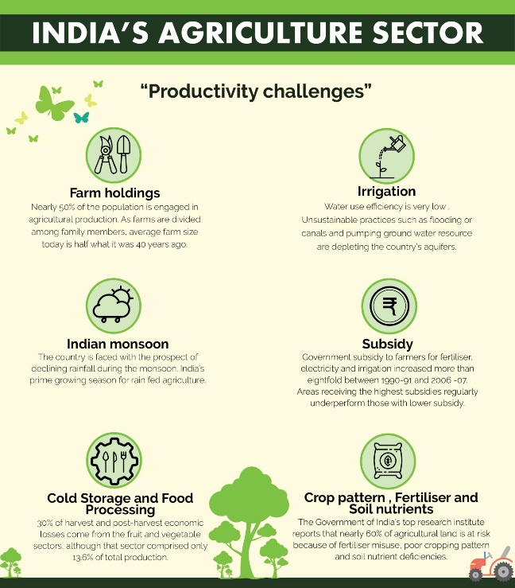

**Figure 3.1 –** Problems faced by farmers

We’ve also included fertilizer calculator in our app. Fertilizer Calculator was developed to assist farmers whose fertilizer needs require adjustment from the standard soil test recommendation due to a change in units, availability of fertilizer products, and/or a difference in land size. Farmers can use it to calculate the weight of fertilizer materials to supply the amounts of N, P2O5, K2O, S recommended by a soil test report.

* 1. **Objective & Scope**
* **Objectives**
* Develop a system that capable to detect and identify the type of disease on the most of the plants.
* Provide the farmer with the current weather details as per his location.
* Keep the farmer up to date by providing daily news of various sectors.
* Help farmer to find the current market price of any vegetables and fruits in various states and districts.
* Help farmer remember and prioritize his daily tasks by using to To-Do-List.
* Help farmer calculate the right composition of fertilizers.
* **Scope**
* Detect and identify plants diseases of Corn, Tomato, Potato, Apple, Cherry, and Grape.
* Provide the solutions for detected diseases of Corn, Tomato, Potato, Apple, Cherry, and Grape.
* Get current weather details as per the location.
* Show daily news from different sectors like business, sports, entertainment, technology, science, health, and education.
* Create new tasks and delete completed tasks in the To-Do-List.
* Calculate the right composition of fertilizers with amount of Nitrogen (N), Phosphorous (P) and Potassium (K) with respect to area of farm land.
  1. **Applying software engineering approach**
* **Incremental Approach**

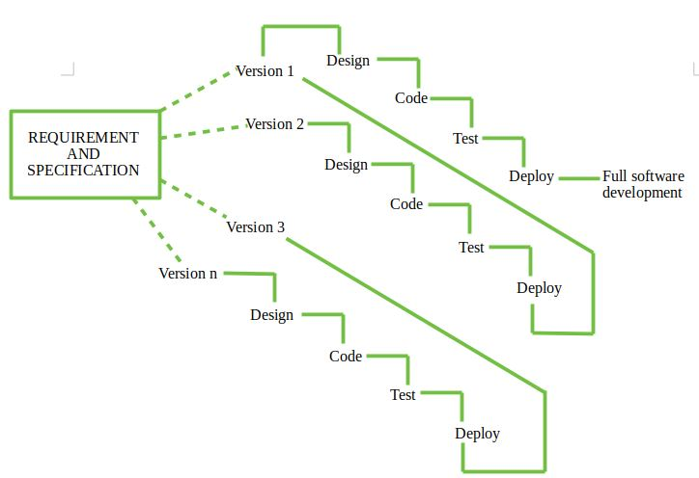

**Figure 4.1 –** Incremental approach

* **What is incremental approach?**

Requirements of Software are first broken down into several modules that can be incrementally constructed and delivered. At any time, the plan is made just for the next increment and not for any kind of long term plan. Therefore, it is easier to modify the version as per the need of the customer. The development Team first undertakes to develop core features (these do not need services from other features) of the system.

Once the core features are fully developed, then these are refined to increase levels of capabilities by adding new functions in Successive versions. Each incremental version is usually developed using an iterative waterfall model of development.

As each successive version of the software is constructed and delivered, now the feedback of the Customer is to be taken and these were then incorporated into the next version. Each version of the software has more additional features than the previous ones.

* **When to use incremental approach?**
* This model can be used when the requirements of the complete system are clearly defined and understood.
* Major requirements must be defined; however, some details can evolve with time.
* There is a need to get a product to the market early.
* A new technology is being used.
* Resources with needed skill set are not available.
* There are some high risk features and goals.
* **Advantages of incremental approach**
* Generates working software quickly and early during the software life cycle.
* This model is more flexible – less costly to change scope and requirements.
* It is easier to test and debug during a smaller iteration.
* In this model customer can respond to each built.
* Lowers initial delivery cost.
* Easier to manage risk because risky pieces are identified and handled during it’d iteration.
* **Disadvantages of incremental approach**
* Needs good planning and design.
* Needs a clear and complete definition of the whole system before it can be broken down and built incrementally.
* Total cost is higher than waterfall.
* **Why we used incremental approach?**

We fixed our application requirements during the requirement gathering phase. As requirements were not likely to change later so we decided to follow incremental approach for creating our application. Our application contains total 6 features namely disease detection, weather details, news, market price, to-do-list and fertilizer calculator. Those are the six main requirements of our project. Hence we divided each feature as an increment and started working on each of them.

1. **LITERATURE SURVEY**

There are lots of techniques to detect the different types of diseases in plants in its early stages. Conventional method of plant disease detection is naked eye observation methods and it is non effective for large crop. Using digital image processing method, the disease detection in plant is efficient, less time consuming and accurate. This technique saves time, efforts, labors and use of pesticides. Different authors propose different techniques with the help of digital image processing for accurate plants disease identification. Lots of algorithms have developed by different researchers for image processing.

In paper [1], authors present image processing technique for Rice disease identification and considered the two most common diseases in the north east India, namely Leaf Blast (Magnaporthe Grisea) and Brown Spot (Cochiobolus Miyabeanus). Image acquisition is basic step, after that author use segmentation, boundary detection and spot detection method for feature extraction of the infected parts of the leave. In this paper author introduces zooming algorithm in which SOM (Self Organizing Map) neural network is used for classification diseased rice images. There are two methods to make input vector in SOM. First method is the padding of zeros and the second method is the interpolation of missing points. For fractional zooming to normalize the spots size, interpolation method is applied. Image transformation in frequency domain does not give better classification. For testing purposes, four different types of images are applied; the zooming algorithm gives satisfactory results of classification for test images.

In paper [2], authors present image-processing technique for Leaf & stem disease detection. The author used a set of leaf images from Jordan’s Al-Ghor area. The five plant diseases namely: Early scorch, Ashen mold, Late scorch, Cottony mold and Tiny whiteness is tested by image processing technique. In this technique at starting, image acquisition is obtained and then K-Means clustering method is used for segmentation. After that in feature extraction, CCM (Color Co-occurrence Method) is used for texture analysis of infected leaf and stem. Lastly paper presents back propagation algorithm for neural network in classification of plant diseases. Result of this image processing technique shows accurate detection and classification of plant diseases with high precision around 93%.

In paper [3], authors used both LABVIEW and MATLAB software for image processing to detect chili plant disease. This combined technique detects disease through leaf inspection in early stage. The Image is captured using LABVIEW IMAQ Vision and MATLAB is used for further operations of image processing. Image pre-processing operations are Fourier filtering, edge detection and morphological operations. In feature extractions, the color clustering is used to distinguish between chili and non-chili leaves. Then image recognition and classification determine the healthiness of each chili plant. This technique results in reducing use of harmful chemicals for chili plant which reduces production cost and increases high quality of chili.

In paper [4], authors have presented image processing technique for detecting the Malus Domestica leaves disease. Intensity values of grayscale images are obtained by histogram equalization method. In image segmentation, Co-occurrence matrix method algorithm is used for texture analysis and K-Means clustering algorithm is used for color analysis. Texture analysis is characterization of regions in an image by texture content. Color analysis refers to minimizing the sum of squares of distance between objects and class centroid or corresponding cluster. In threshold matching process individual pixels value is compared with threshold value, if value is greater than threshold then it is marked as object pixel. The texture and color analysis images are compared with the previous images for detection of plant diseases. Author will use Bayes and K-means clustering in future.

In paper [5], authors present image processing techniques for detecting the Bacterial infection in plant. Common infection seen on plant is Bacterial leaf scorch and early detection of this helps in improvement of plant growth. The image processing starts with image acquisition which involves basic steps such as capturing of image and converting it to computer readable format. Then clustering is done to separate foreground and background image with help of K-means clustering method in image segmentation. Clustering is based on intensity mapping and leaf area highlighting is done by subtracting the clustered leaf images from base images. Compared to Fuzzy logic, K-means clustering algorithm is simple and effective in detecting the infected area with reduced manual cluster selection requirement. With ADSP target boards and FPGA tools, further implementation is possible.

In paper [6], authors present image processing technique for detection of unhealthy region of Citrus leaf. There are four types of citrus diseases namely: (i) Citrus canker, (ii) Anthracnose, (iii) Overwatering, (iv) Citrus greening. Author proposed methodology in which image acquisition is first step for capturing image by digital camera in high resolution to create database. Color space conversion and image enhancement is done in image pre-processing. Discrete cosine transform domain is used for color image enhancement. YCbCr color system and L*a*b* color space are chosen for color space conversion. In feature extraction author present statistical method, using Gray-Level Co-occurrence Matrix (GLCM) to see statistics such as contrast, energy, homogeneity and entropy using graycoprops function. Two types support vector machine (SVM) classifiers: SVMRBF and SVMPOLY are used for differentiating citrus leaf diseases.

In paper [7], authors present image processing technique for Orchid leaf disease detection. Black leaf spot and Sun scorch are two types of orchid leaf diseases mostly found. The basic step of image processing is image acquisition for capturing images and stores it in computer for further operation. Image pre-processing involves histogram equalization, intensity adjustment and filtering for enhancing or modifying the image. Three morphological processes are used in border segmentation technique for remove small object and preserve large object in image. Thresholding in segmentation is used for start and stop point of line to trace edges. Author added ROI (region of interest) in GUI. After the border segmentation process a classification is done by calculating white pixels in image. This system gives high accuracy and low percentage of error in result.

In paper [8], authors present image processing technique for Tomato leaves diseases detection. In image acquisition phase, digital images of infected tomato leaves are collected which include two types of tomato diseases namely: Early blight and Powdery mildew. In pre-processing phase some techniques are techniques are applied for image enhancement, smoothness; remove noise, image resizing, image isolation, and background removing. Author introduced Gabor wavelet transformation and Support vector machine for identification and classification of tomato diseases. In feature extraction phase with the help of Gabor wavelet transform feature vectors are obtained for next classification phase. In classification phase, support vector machine (SVM) is trained for identifying the category of tomato diseases. The inputs of SVM are feature vectors and corresponding classes, whereas the outputs are the decision that detect tomato’s leaf disease. SVM is employed using Invmult Kernel, Cauchy Kernel and Laplacian Kernel functions. Grid search and N-fold cross-validation techniques are used for performance evaluation.

In paper [9], authors described disease detection, in which image processing is first step for obtaining image in digital form and pre-processing to remove noise and other object from image. Pre-processing also convert RGB images into grey images using equation f(x) = 0.2989*R + 0.5870*G + 0.114*B and makes histogram equalization. Image segmentation is done using boundary and spot detection algorithms for finding infected part of leaf. Classifications of objects are done using K-means clustering method. Otsu threshold algorithm is used for thresholding which creates binary images from grey images. With the help of feature extraction color, texture, morphology, edges are used in plant disease detection. Leaf color extraction using H & B components and Color co-occurrence method are feature extraction methods in image processing. Classifications of diseases are done using artificial neural network (ANN) and Back propagation network.

In paper [10], authors present image processing technique to detect Scorch and Spot diseases of plant. First step is RGB image acquisition of plant. Then in preprocessing color transformation structure is created and color values in RGB are converted to the space. The masking of green-pixels is done after applying K-means clustering. This removes masked cells inside the boundaries of infected clusters. Image segmentation is done to obtain the useful segments in image. In feature extraction, color, texture and edge features are computed using color co-occurrence methodology. Neural Networks is configured for recognition and classification of diseases. Future work will include analyzing citrus trees disease conditions in outdoor environment.

In paper [11], authors present image processing technique for Groundnut plant disease detection. Groundnut plant has two major diseases namely: Early leaf spot (Cercospora) and Late leaf spot (Cercosporidium personatum). After obtaining leaf images in RGB are converted to HSV color images. Green colored pixels in image are found out to reduce processing time. In color and texture feature extraction analysis, co-occurrence matrices technique is used. In texture feature extraction there are two ways to analyze the texture images. First method is structured approach and second method is statistical approach. Author used statistical approach in this paper. Back propagation algorithm is applied for classification and recognition of groundnut diseases. In back propagation two type of phase are there namely: 1) propagation and 2) weight update. Authors classified four different diseases with 97 % of efficiency.

In paper [12], authors described plant disease recognition technique, in which first phase is to create color transformation structure for the RGB leaf image and convert color values from RGB to the space specified in that structure. Then apply color space transformation and image is segmented using the K-means technique. In the second phase called as Masking of green pixels, the unnecessary part such as green area within leaf area is removed. In third phase authors calculate the texture features for the segmented infected object also remove masked cells inside the boundaries of the infected cluster. Infected cluster are converted from RGB to HSI and SGDM matrix is generated for H and S. In the fourth phase GLCM function is used to calculate the features and compute of texture statistics. Finally, the extracted features are passed through pretrained neural network for disease recognition.

In paper [13], authors present image processing technique for detecting disease of Sugarcane leaf. Authors choose 6 type of disease for experiment, they are: Brown Spot, Downy mildew, Sugarcane Mosaic, Red stripe, Red rot and Downy Fungal. In image acquisition, images are captured in better quality resolutions with format such as TIF, PNG, JPEG and BMP for image-analysis. In preprocessing RGB images are converted to grayscale and unwanted part of data from the images is removed. Segmentation locates healthy area of given image which contains green pixels and potentially infected area. Three algorithms namely: Linear SVM, Nonlinear SVM and Multiclass SVM are used in feature extraction for disease detection.

Savita N. et al. [14] studied various classification techniques for plant leaf diseases. Each pattern of distinct classes is classified in classification technique based on their morphological features. Various techniques such as Artificial neural network, Probabilistic Neural Network, Genetic Algorithm, k-Nearest Neighbor, Principal Component Analysis and Fuzzy logic. It is a difficult task to select a classification method because every classification methods have its own disadvantage and advantage. This paper helps to finalize which classification method is suitable for a particular application. K-Nearest-Neighbor method is one of the simplest algorithms to test classes but it is very time complex with making predictions. Neural networks have ability to tolerate noisy input but having hard to understand algorithm structure. For classifying high-dimensional data set SVM (Support Vector Machine) found to be the best available machine learning algorithm. In SVM, quadratic optimization helps to control complexity of frequency of error and decision rule but it is very difficult to find optimal parameter for training nonlinear data which makes SVM more complex to implement.

Prof. Sanjay et al. [15] introduced that automatic detection of plant leaf can prevent serious outbreak. The fact that morphology with their reproductive structure can be used to identify fungi was identified. Bacteria have simpler life cycle and generally have single cell. It divides into two cells during binary fission and increase in numbers. Viruses are non-protein associated protein and genetic material based extremely small particle. They developed a processing scheme with four steps. First, takes input RGB image and creates color transformation. Second, Conversion from RGB to HIS take place for color descriptor. Third, masking of pixel and removal of unwanted color using specific threshold, based on that extraction of useful segmentation has been done. Fourth, compute the statistics from SGDM matrices and evaluate plant leaf diseases.

Mr. Pramod and S. landgeet [16] proposed an image processing based software methodology for plant diseases detection and classification. They explains how Indian farmers faces problem with plant diseases due to lack of agricultural expert access. In this paper, their objective was to develop an image processing technique to automatically recognize plant diseases based on their shape, texture and color. After detection of cause or plant diseases this system gives fast and instant information to farmers with SMS. This system will reduce cost, chemical testing procedure, & time and enhance productivity.

Anand. H. Kulkarni and Ashwin Patil R. K [17] described a methodology to accurately detecting plant diseases. This methodology includes image processing techniques along with artificial neural network (ANN). They also discuss about the dramatic problems of farmers and present a work aimed to develop diseases detection system for plant. This system first capture raw image of plants. Then, Filter and Segment it by Gabor filter. Then, extract the color information from segmented image. Now well trained ANN is used to distinguish between healthy and diseased plant sample. Color and texture are two precious parameters for ANN based classifier. This system runs with real time constraints and shows 91% accuracy on implementation.

Haiguang Wang et al. [18] proposed a model to improve accuracy of image recognition and diagnosis of plant diseases. Two kinds of wheat disease (wheat stripe rust and leaf rust) and grapes diseases (grape downy mildew and powdery mildew) were under inspection. Image processing which includes image compression, image cropping and image de-noising along with k-means clustering algorithms for segmentation had been used for image recognition. 25 texture features, 21 color features and 4 shape features were extracted from the each image. Back propagation (BP) algorithms based classifier used to detect diseases. Results show, back propagation networks are extremely effective to identification of diseases. Principal Component Analysis (PCA) is used to features the dimension data. As an optimal resolution result prediction accuracy and fitting accuracy for the grape diseases were 100%. For wheat too it is 100% both. When feature data dimensions were reduced by PCA, prediction accuracy was 97.14% and fitting accuracy was 100% for grapes diseases optical recognition, and both fitting accuracy and the prediction accuracy were 100% for wheat diseases.

Piyush Chaudhary et al. [19] proposed an algorithm for spot segmentation for plant leaf diseases using image processing technique. According to the classification of plant diseases is the very first and significant stage for plant detection. In comparison to plant leaf color, diseases spots are same in colors but different in intensities. So RBG color transform can be a better choice for diseases spot segmentation. In this paper, effect of HSI, CIELAB color and YCbCrspaces comparison has been done for spot detection. Image smoothing is achieved through median filter. Otsu method of threshold calculation is applied to detect disease spot on color component. Various “Dicot” and “Monocot” family plants leaves were analyzed in both noisy and noise free (white) background. Developed algorithm is independent of diseases spot color, plant type and background noise.

M. Egmont-Petersen [20] categorized various applications for image processing algorithms. Categorization is achieved with as a two dimensional taxonomy. One dimension of which specifies object recognition, data reduction/feature extraction, preprocessing, segmentation, optimization and image understanding. Second dimension takes input data and perform various abstraction level task as structure-level, object-set-level, pixel-level, object-level local feature-level and scene characterization.

Muhammad Faisal Zafar et al. [21] proposed the grape leaf diagnosis system. It has three main parts: firstly complex back ground color extraction, secondly color extraction diseased part of leaf and at last disease classification. Color analysis has been done with the help of self-organizing feature map with back propagation neural network. GA and MSOFM are employed for leaf disease segmentation further SVM is deployed for classification. After these processes filtration of image has been done through Gabor Wavelet and applied to SVM for classification of final disease. Grapes leaf diseases are classify into three categories in this system: Rust disease, Scab disease and No disease. This system shows wide performance for agricultural implementation.

Jayme Garcia and Arnal Barbedo [22] presented a survey on various image processing methodology to classify, quantify and detect plant diseases in a visible spectrum. The analysis has been done only on the leaves on the system to keep the survey on short. Smita Naikwadi and Niket Amoda, show a software evolution for plant leaf diseases detection and classification. Two steps are successively added after the segmentation process. Firstly they identify pixels having most green color. Secondly mask this pixel with Otsu’s method on a specific threshold value. Addition to that, all the pixels with zeros, red, green and blue values and boundary pixels has been completely removed. Experimental results shows robust technique for plant leaf diseases is obtained.

|  |  |
| --- | --- |
| **Paper** | **Techniques Used** |
| [1] Rice Disease identification using Pattern Recognition Techniques | Zooming algorithm, SOM neural network |
| [2] A Framework for Detection and Classification of Plant Leaf and Stem Diseases | K-Means clustering, Back propagation algorithm, CCM |
| [3] Feasibility Study on Plant Chili Disease Detection Using Image Processing Techniques | Morphological processing, Color clustering, LABVIEW IMAQ Vision |
| [4] Remote Area Plant Disease Detection Using Image Processing | CCM, K-Means clustering |
| [5] A Novel Algorithm for Detecting Bacterial Leaf Scorch (BLS) of Shade Trees Using Image Processing | K-means clustering algorithm, Intensity mapping |
| [6] Unhealthy Region of Citrus Leaf Detection Using Image Processing Techniques | GLCM, SF-CES, SVMRBF & SVMPOLY classifier |
| [7] Orchid Leaf Disease Detection using Border Segmentation Techniques | Border segmentation, Pattern classification |
| [8] Tomato leaves diseases detection approach based on support vector machines | SVM, Gabor wavelet transform |
| [9] Plant Disease Detection Using Image Processing | Otsu thresholding, ANN, SVM, Back propagation network |
| [10] Advance in Image Processing for Detection of Plant Diseases | CCM, Neural network |
| [11] Groundnut Leaf Disease Detection and Classification by using Back Propagation Algorithm | CCM, Back propagation algorithm |
| [12] Plant Leaf Disease Detection and Classification Using Image Processing Techniques | RGB to HSI, K-means clustering, SGDM Matrix, GLCM |
| [13] Leaf Disease Detection and Prevention Using Image processing using Matlab | Linear SVM, Non Linear SVM and Multiclass SVM |

**Table 3.1 -** Summary of related work on plant-disease detection

1. **REQUIREMENT SPECIFICATION**
   1. **Software Requirements**

* Android OS – V 5.1.1 (Minimum)
  1. **Minimum Hardware Requirements**
* Any Android Smartphone
* Inbuilt Camera Support
* GPS Support
* Internet Connection (Minimum speed 512 Kbps)
* Storage Space (Minimum 100 MB)

1. **SYSTEM DESIGN**
   1. **Architecture Design**

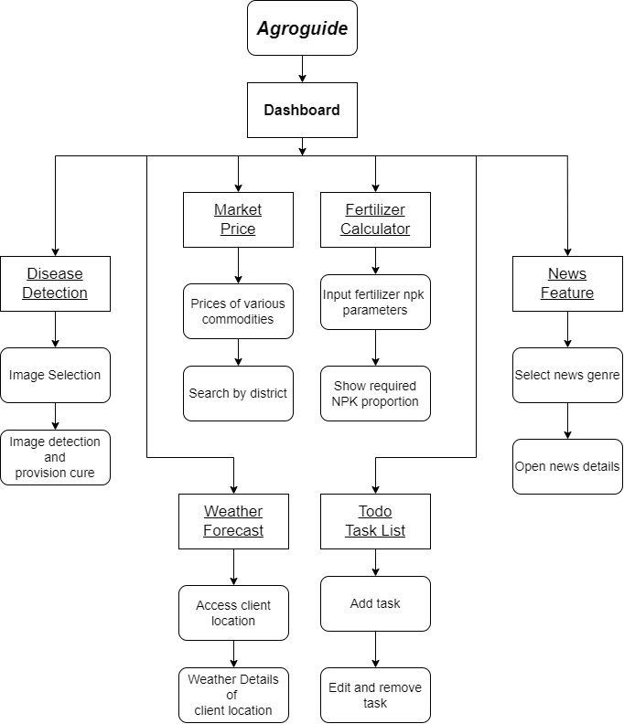

**Figure 5.1 –** AgroGuide Architecture Design

* 1. **Dataflow Diagram**

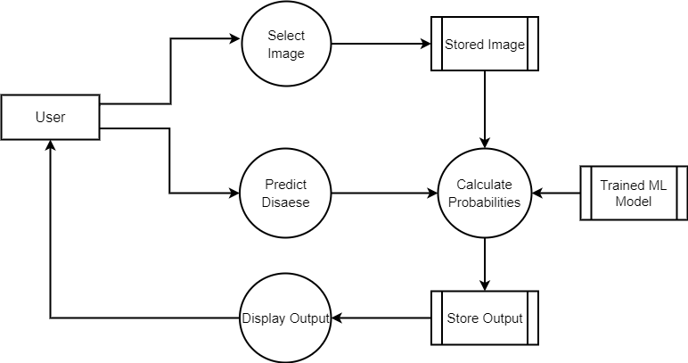

**Figure 5.2 –** AgroGuide Data Flow Diagram

* 1. **Sequence Diagram**

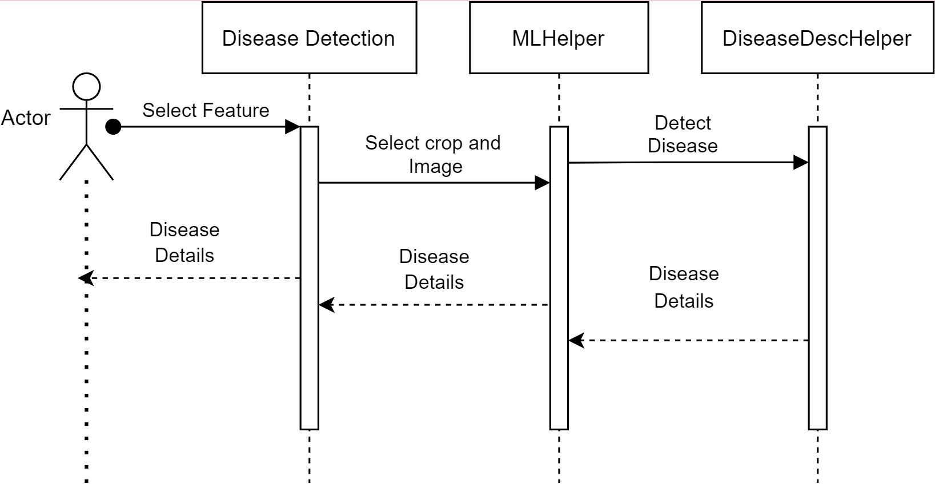

**Figure 5.3 –** AgroGuide Sequence Design

* 1. **Database Design**
* **User Table :-**

| Column | Type | Null | Default |
| --- | --- | --- | --- |
| Username | varchar(30) | No | None |
| FullName | varchar(40) | No | None |
| Email | varchar(30) | No | None |
| PhoneNo | varchar(10) | No | None |
| Password | varchar(30) | No | None |

|  |  |  |  |  |  |  |
| --- | --- | --- | --- | --- | --- | --- |
| **Keyname** | **Type** | **Unique** | **Packed** | **Column** | **Auto-Increment** | **Null** |
| Primary | STING | YES | No | Username | No | No |

**Table 4.1 –** User Table Database Design

* **Tasks Table :-**

| Column | Type | Null | Default |
| --- | --- | --- | --- |
| TaskId | int(16) | No | None |
| TaskContent | varchar(400) | No | None |
| TaskStatus | bit | No | None |
| TaskCreationDate | DateTime | No | None |
| TaskUpdationDate | DateTime | No | None |

|  |  |  |  |  |  |  |
| --- | --- | --- | --- | --- | --- | --- |
| **Keyname** | **Type** | **Unique** | **Packed** | **Column** | **Auto-Increment** | **Null** |
| Primary | int(16) | YES | No | TaskId | Yes | No |

**Table 4.1 –** Tasks Table Database Design

* 1. **E-R Diagram**

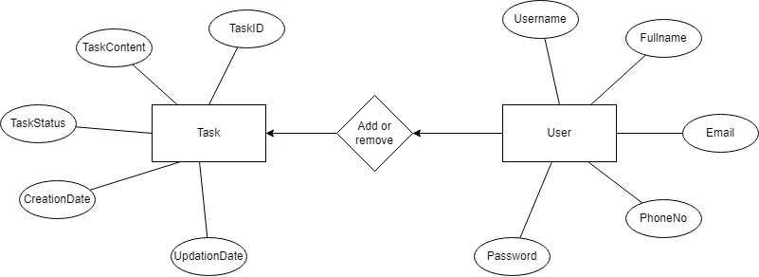

**Figure 5.4 –** AgroGuide E-R Diagram

1. **TECHNICAL SPECIFICATION**
   1. **Python 3.6.12**

Python is an interpreter, object-oriented, high-level programming language with dynamic semantics. Its high-level built in data structures, combined with dynamic typing and dynamic binding; make it very attractive for Rapid Application Development, as well as for use as a scripting or glue language to connect existing components together. Python's simple, easy to learn syntax emphasizes readability and therefore reduces the cost of program maintenance. Python is dynamically-typed and garbage-collected. It supports multiple programming paradigms, including structured (particularly, procedural), object-oriented and functional programming. It is often described as a "batteries included" language due to its comprehensive standard library. Guido van Rossum began working on Python in the late 1980s, as a successor to the ABC programming language, and first released it in 1991 as Python 0.9.0. Python 2.0 was released in 2000 and introduced new features, such as list comprehensions and a cycle-detecting garbage collection system (in addition to reference counting). Python 3.0 was released in 2008 and was a major revision of the language that is not completely backward-compatible. Python 2 was discontinued with version 2.7.18 in 2020. Python consistently ranks as one of the most popular programming languages.

* **Features of Python**
* Easy to Code
* Open Source and Free
* Support for GUI
* Object-Oriented Approach
* High-Level Language
* Integrated by Nature
* Highly Portable
* Highly Dynamic
  1. **Python Modules**
* **TensorFlow 1.6.0**

TensorFlow is an end-to-end open source platform for machine learning. It has a comprehensive, flexible ecosystem of tools, libraries and community resources that lets researchers push the state-of-the-art in ML and developers easily build and deploy ML powered applications.

TensorFlow, developed by Google Brain team, is an open source software library for a building machine learning models for range of tasks in data science. It is written in Python, C++ & CUDA and is mainly used for machine learning applications such as neural networks. The open source software library has had many releases, each one with more improvements and fixes. Google recently announced the release of TensorFlow 1.5.0 in January, which included Eager Execution of TensorFlow and developer preview of TensorFlow Lite as major additions to the library. Google’s contribution to the world of Machine Learning and Data Science did not end with that. A new version, TensorFlow 1.6.0 has been released, with significant changes over the previously existing versions.



* **NumPy**

NumPy is a library for the Python programming language, adding support for large, multi-dimensional arrays and matrices, along with a large collection of high-level mathematical functions to operate on arrays. NumPy can be used to perform a wide variety of mathematical operations on arrays. It adds powerful data structures to Python that guarantee efficient calculations with arrays and matrices and it supplies an enormous library of high-level mathematical functions that operate on these arrays and matrices.

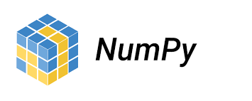

* 1. **PyCharm Community Edition**

PyCharm is a dedicated Python Integrated Development Environment (IDE) providing a wide range of essential tools for Python developers, tightly integrated to create a convenient environment for productive Python, web, and data science development.

* **Features**
* Coding assistance and analysis, with code completion, syntax and error highlighting, linter integration, and quick fixes
* Project and code navigation: specialized project views, file structure views and quick jumping between files, classes, methods and usages
* Python refactoring: includes rename, extract method, introduce variable, introduce constant, pull up, push down and other
* Support for web frameworks: Django, web2py and Flask [professional edition only] - Integrated Python debugger Integrated unit testing, with line-by-line code coverage
* Google App Engine Python development [professional edition only]
* Version control integration: unified user interface for Mercurial, Git, Subversion, Perforce and CVS with change lists and merge
* Support for scientific tools like matplotlib, numpy and scipy [professional edition only]



* 1. **Java**

Java is a high-level, class-based, object-oriented programming language that is designed to have as few implementation dependencies as possible. It is a general purpose programming language intended to let programmers write once, run anywhere (WORA), meaning that compiled Java code can run on all platforms that support Java without the need for recompilation. Java applications are typically compiled to bytecode that can run on any Java virtual machine (JVM) regardless of the underlying computer architecture. The syntax of Java is similar to C and C++, but has fewer low-level facilities than either of them. The Java runtime provides dynamic capabilities (such as reflection and runtime code modification) that are typically not available in traditional compiled languages.

* **Features**
* Object Oriented. In Java, everything is an Object
* Platform Independent
* Simple
* Secure
* Architecture-neutral
* Portable
* Robust
* Multithreaded



* 1. **JDK 11**

The Java Development Kit (JDK) is a cross-platform software development environment that offers a collection of tools and libraries necessary for developing Java-based software applications and applets. It is a core package used in Java, along with the JVM (Java Virtual Machine) and the JRE (Java Runtime Environment).

Beginners often get confused with JRE and JDK, if you are only interested in running Java programs on your machine then you can easily do it using Java Runtime Environment. However, if you would like to develop a Java-based software application then along with JRE you may need some additional necessary tools, which is called JDK.

The Java Runtime Environment in JDK is usually called Private Runtime because it is separated from the regular JRE and has extra contents. The Private Runtime in JDK contains a JVM and all the class libraries present in the production environment, as well as additional libraries useful to developers, e.g. internationalization libraries and the IDL libraries.

* **JDK contains:**
* Java Runtime Environment (JRE)
* An interpreter/loader (Java)
* A compiler (javac)
* An archiver (jar) and many more.

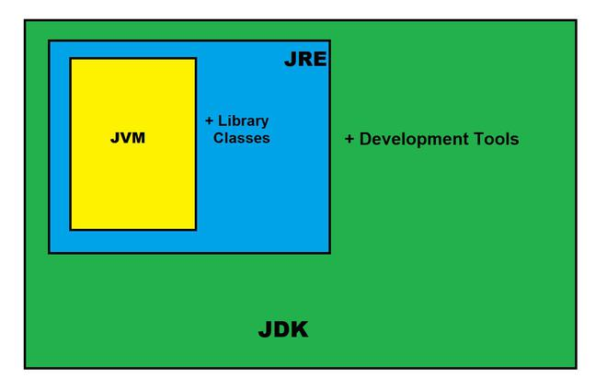

* 1. **Android OS**

Android is a mobile operating system based on a modified version of the Linux kernel and other open source software, designed primarily for touchscreen mobile devices such as smartphones and tablets. Android is developed by a consortium of developers known as the Open Handset Alliance and commercially sponsored by Google. It was unveiled in November 2007, with the first commercial Android device, the HTC Dream, being launched in September 2008.

Most versions of Android are proprietary. The core components are taken from the Android Open Source Project (AOSP), which is free and open-source software (FOSS) primarily licensed under the Apache License. When Android is installed on devices, ability to modify the otherwise FOSS software is usually restricted, either by not providing the corresponding source code or preventing reinstallation through technical measures, rendering the installed version proprietary.

Most Android devices ship with additional proprietary software pre-installed, most notably Google Mobile Services (GMS) which includes core apps such as Google Chrome, the digital distribution platform Google Play, and associated Google Play Services development platform. Over 70 percent of Android smartphones run Google's ecosystem; some with vendor-customized user interface and software suite, such as TouchWiz and later One UI by Samsung, and HTC Sense. Competing Android ecosystems and forks include Fire OS (developed by Amazon), ColorOS by OPPO, OriginOS by vivo and MagicUI by Honor or custom ROM such as LineageOS. However, the "Android" name and logo are trademarks of Google which imposes standards to restrict the use of Android branding by "uncertified" devices outside their ecosystem. The source code has been used to develop variants of Android on a range of other electronics, such as game consoles, digital cameras, portable media players, PCs, each with a specialized user interface.

Some well-known derivatives include Android TV for televisions and Wear OS for wearables, both developed by Google. Software packages on Android, which use the APK format, are generally distributed through proprietary application stores like Google Play Store, Amazon Appstore (including for Windows 11), Samsung Galaxy Store, Huawei AppGallery, Cafe Bazaar, and GetJar, or open source platforms like Aptoide or F-Droid.

Android has been the best-selling OS worldwide on smartphones since 2011 and on tablets since 2013. As of May 2021, it has over three billion monthly active users, the largest installed base of any operating system, and as of January 2021, the Google Play Store features over 3 million apps. Android 12, released on October 4, 2021, is the latest version.

* **Features**
* Beautiful UI
* Connectivity
* SQLite Database
* Media Support
* Multi-touch
* Multitasking
* Resizable Widgets



* 1. **Android Studio**

Android Studio is the official integrated development environment (IDE) for Android application development. It is based on the IntelliJ IDEA, a Java integrated development environment for software, and incorporates its code editing and developer tools.

To support application development within the Android operating system, Android Studio uses a Gradle-based build system, emulator, code templates, and Github integration. Every project in Android Studio has one or more modalities with source code and resource files. These modalities include Android app modules, Library modules, and Google App Engine modules.

Android Studio uses an Instant Push feature to push code and resource changes to a running application. A code editor assists the developer with writing code and offering code completion, refraction, and analysis. Applications built in Android Studio are then compiled into the APK format for submission to the Google Play Store

The software was first announced at Google I/O in May 2013, and the first stable build was released in December 2014. Android Studio is available for Mac, Windows, and Linux desktop platforms. It replaced Eclipse Android Development Tools (ADT) as the primary IDE for Android application development. Android Studio and the Software Development Kit can be downloaded directly from Google.



* 1. **Android Dependencies**
* **Firebase 20.0.4**

The Firebase Real-time Database lets you build rich, collaborative applications by allowing secure access to the database directly from client-side code. Data is persisted locally, and even while offline, real-time events continue to fire, giving the end user a responsive experience. When the device regains connection, the Real-time Database synchronizes the local data changes with the remote updates that occurred while the client was offline, merging any conflicts automatically.

The Real-time Database provides a flexible, expression-based rules language, called Firebase Real-time Database Security Rules, to define how your data should be structured and when data can be read from or written to. When integrated with Firebase Authentication, developers can define who has access to what data, and how they can access it.

The Real-time Database is a NoSQL database and as such has different optimizations and functionality compared to a relational database. The Real-time Database API is designed to only allow operations that can be executed quickly. This enables you to build a great real-time experience that can serve millions of users without compromising on responsiveness. Because of this, it is important to think about how users need to access your data and then structure it accordingly.



* **TensorFlow Lite 0.1.0**

TensorFlow Lite is a set of tools that enables on-device machine learning by helping developers run their models on mobile, embedded, and edge devices.

* **Key features**
* Optimized for on-device machine learning, by addressing 5 key constraints: latency (there's no round-trip to a server), privacy (no personal data leaves the device), connectivity (internet connectivity is not required), size (reduced model and binary size) and power consumption (efficient inference and a lack of network connections).
* Multiple platform support, covering Android and iOS devices, embedded Linux, and microcontrollers.
* Diverse language support, which includes Java, Swift, Objective-C, C++, and Python.
* High performance, with hardware acceleration and model optimization.
* End-to-end examples, for common machine learning tasks such as image classification, object detection, pose estimation, question answering, text classification, etc. on multiple platforms.
* **SquareUp Picasso 2.71**

Picasso is open source and one of the widely used image download libraries in Android. It is created and maintained by Square. It is among the powerful image download and caching library for Android. Picasso simplifies the process of loading images from external URLs and displays them on your application. For example, downloading an image from the server is one of the most common tasks in any application. And it needs quite a larger amount of code to achieve this via android networking API. By using Picasso, you can achieve this with a few lines of code.

* Many common pitfalls of image loading on Android are handled automatically by Picasso:
* Handling ImageView recycling and download cancelation in an adapter.
* Complex image transformations with minimal memory use.
* Automatic memory and disk caching.
* **SquareUp Retrofit 2.1.0**

Retrofit is type-safe REST client for Android and Java which aims to make it easier to consume RESTful web services. We’ll not go into the details of Retrofit 1.x versions and jump onto Retrofit 2 directly which has a lot of new features and a changed internal API compared to the previous versions.

Retrofit 2 by default leverages OkHttp as the networking layer and is built on top of it. Retrofit automatically serializes the JSON response using a POJO (Plain Old Java Object) which must be defined in advanced for the JSON Structure. To serialize JSON we need a converter to convert it into Gson first. We need to add the following dependencies in our build.grade file.

* 1. **Computer System (Windows 10)**

Windows 10 is an operating system from Microsoft based on the new version of Windows which was released on 30 September 2014 and hit the market in October 2014. The Glimpse version of it was already available. All of them can also download the full version of it. It is providing free of cost to the customers who have purchased earlier operating system 7, 8 etc. Since the announcement of the discontinuation of Windows 7, the demand for the Windows 10 operating system has increased. Windows 10 has started replacing Windows 8. Microsoft wanted to create an ecosystem for all its devices and software. For which it needed a single, secure and fast platforms which has been proved by making Windows 10.

It has fulfilled this need by developing Windows 8 and launched Windows 10 instead of Windows 9 version which does a similar job for computers, mobile phones, tablets, gaming devices and internet devices. You do not need a separate operating system for each device. One operating system works smoothly on all devices. Windows 10 handles problems like screen size, screen type, hardware compatibility, etc.



* 1. **CPU (AMD Ryzen 5)**

Ryzen 5 (pronounced Rye-Zen Five) is a family of mid-range performance 64-bit quad and hexa-cores x86 microprocessors introduced by AMD in March of 2017. Ryzen 5 is based on the Zen microarchitecture and is manufactured on GF's 14 nm process. Ryzen 5 is marketed toward the mid-range performance market. The Ryzen 5 is positioned against Intel's mid-range mainstream Core i5 processors, offering competitive performance at lower prices. Introduced in April 2017, the Ryzen 5 family is aimed at mid-range performance desktop and sport either 4 or 6 cores. The Ryzen 5 is situated under the Ryzen 7 family, offering all of the features but fewer cores.

1. **SYSTEM MODULES**
   1. **Weather**

While farmers must make many day-to-day decisions related to weather conditions Most people know that the weather has a significant impact on the agriculture industry. Indeed, crops need the basics of moisture, warmth, and sun to thrive. But what’s less obvious is how the details of weather information can drive a grower’s business decisions, helping them to plan efficiently, minimize costs and maximize yields and profits as a result. So for that reason we introduce weather detestation feature in our application. Our whether detestation feature shows min temperature, max temperature, sunrise, sunset, wind speed, wind pressure, humidity etc.. which help farmer to manage the farm properly. For this we use OpenWeathermap's Current Weather API this api provides the world’s most sophisticated weather intelligence. forecast for every longitude and latitude point on Earth with Superior Accuracy.

Most people know that the weather has a significant impact on the agriculture industry. Indeed, crops need the basics of moisture, warmth, and sun to thrive. But what’s less obvious is how the details of weather information can drive a grower’s business decisions, helping them to plan efficiently, minimize costs and maximize yields—and profits—as a result.

While farmers must make many day-to-day decisions related to weather conditions, there are four primary areas of farming that are fundamentally affected impacted by weather:

* Crop Growth/Irrigation: Crop growth, or crop yield, requires appropriate amounts of moisture, light, and temperature. Detailed and accurate historical, real-time and forecast weather information can help farmers better understand and track the growth status/stage to make informed decisions. Having access to this data can guide farmers in making significant and potentially costly decisions, such as whether, when and how much to irrigate.
* Fertilizer Timing and Delivery: One of the many decisions that farmers have to make is determining the proper time to apply fertilizer, as well as the application rate and fertilizer form to use. A misapplied application caused by weather can wipe away the entire field’s profits. Weather forecasts can be used to ensure that fertilizer is applied in the right conditions—when it’s dry enough so that it doesn’t wash away (which would create a waste of resources and money) but moist enough so that it gets worked into the soil.
* Pest and Disease Control: Certain weather conditions encourage the development and growth of pests and diseases, which can destroy crops. Forecast guidance incorporated into pest and disease modeling can help determine whether—and when—it’s appropriate to apply pest or disease controls. Wind forecasts also play a role in this decision, as crop dusters, aircraft that spray fungicidal or insecticidal chemicals on plants from above, must be utilized when wind conditions are not apt to cause sprayed chemicals to miss their targets.
* Field Workability: Field workability refers to the availability of days that are suitable for fieldwork. It’s primarily dependent upon soil moisture and soil temperature. Accurate field-level weather information can help farmers assess the workability of their fields and become more efficient in their day-to-day operations.

The cost/benefit equation for having access to reliable weather forecast information is not always easy to quantify, but it’s a decision that’s easy for most large growers and producers to make. Throughout many months, farmers make small but frequent decisions about their crops, and the cumulative effect of the financial implications of those decisions can be significant.

Irrigation planning is a good example. If a farmer relies on a forecast for precipitation that turns out to be accurate, he saves the cost of unnecessary irrigation. And by having a good idea of the expected amount of rain over a period and irrigating just enough to allow crops to thrive, he will maximize yield.

* *The Role of Weather Forecasting in Precision Agriculture*

Weather information is playing an increasingly instrumental role in the evolving field of precision agriculture, a farming practice that emphasizes accuracy and control when it comes to the growing of crops. An essential aspect of this approach is the use of information technology, which includes weather prediction and other items, such as satellite and aerial imagery, GPS guidance, sensors, drones, variable rate fertilizer application, and crop health indicators.

The ultimate goal of precision agriculture is to maximize growth efficiency at the individual seed and plant level. As a “big data” weather provider, [DTN](https://www.dtn.com/weather/agriculture/weathersentry-global-agriculture-edition/) is excited to provide hyper-local weather data and knowledge that’s being used to help make this goal a reality.

* 1. **Daily News**

News is a vital instrument used for inducing knowledge of agricultural innovations to farmer. Although its public relation role focuses on creating awareness of the new invention, it equally plays a significant role in educating farmers for improved efficiency. News are very important in our day to day life through that we can understand the surrounding condition. So by understanding the importance of news we provide news feature in our application that causes farmer can get the news of various sector. Which help us to understand various thins in societies. Here we use NewsAPI's News API has been the integral element allowing us to offer relevant and timely political news to our users – allowing them to take immediate action to contact their representatives using generated call scripts based on the articles they read. News API is a simple HTTP REST API for searching and retrieving live articles from all over the web.

* 1. **Market Price**

According to various state the daily vegetable prices are continually change. In various places there are various product price so it is important to understand farmer what is the market rate of his product so that he get high cost for his product and he not cheated from brokers. So for that reason, we develop daily market price feature in our application. Which shows daily market price of product of various state. It is most important which make farmer economically stronger Here we use Open Government Data Platform of India’s Daily price of commodities from various markets API This is the Open Government Data Portal designed, developed and hosted by the National Informatics Centre (NIC), a premier ICT organization of the Government of India under the aegis of the Ministry of Electronics & Information Technology. The Objective of Open Government Data Platform India is to facilitate the access to Government owned shareable data and information in both human readable and machine readable forms in a proactive and periodically updatable manner, within the framework of various related policies, Acts and Rules of Government of India, thereby promoting wider accessibility and application of government owned data and unlocking the potential of data for national development.

* 1. **To do list**

To-do lists offer a way to increase productivity, stopping you from forgetting things, helps prioritize tasks, manage tasks effectively, use time wisely and improve time management as well as workflow. With the help of this farmer can manage his daily work properly and also he complete his task within a time.

By keeping such a list, you make sure that your tasks are written down all in one place so you don't forget anything important. And by prioritizing tasks, you plan the order in which you'll do them, so that you can tell what needs your immediate attention, and what you can leave until later.

To-do lists are essential if you're going to beat work overload. When you don't use them effectively, you'll appear unfocused and unreliable to the people around you.

When you do use them effectively, you'll be much better organized, and you'll be much more reliable. You'll experience less stress, safe in the knowledge that you haven't forgotten anything important. More than this, if you prioritize intelligently, you'll focus your time and energy on high-value activities, which will mean that you're more productive, and more valuable to your team.

In fact, it's often when people start to use them effectively and sensibly that they make their first personal productivity breakthroughs, and start making a success of their careers. The video, below, gives some tips on how you can start to use to-do lists more effectively.

* 1. **Fertilizer calculator**

Fertilizers provide crops with essential nutrients like nitrogen, so that the crops grow bigger, faster, and produce more food. But high amount of fertilizer damage the crops so it is necessary to give right amount of fertilizer to the crop. And farmer cannot predict what amount of fertilizer they need to their farm. By understanding this problem we make fertilizer calculator so that shows what amount of fertilizer need to the farm by simply giving input as farm area.

* You can use it to:
* Calculate the weight of fertilizer materials to supply the amounts of N, P2O5, K2O, S recommended by a soil test report.
* Select recommendations in pounds per acre that are typical of agronomic crop recommendations or in pounds per 1000 square feet that are typical of homeowners reports such as for a home lawn.
* Select fertilizer grades different from those given in the recommendation. This is useful when the fertilizer grades in the test report are not available locally.
* Calculate the area of a garden or lawn given the dimensions and shape of the area to be fertilized.
* Calculate fertilizer costs.

1. **ALGORITHM DESCRIPTION**

The architecture of an Inception v3 network is progressively built, step-by-step, as explained below:

1. Factorized Convolutions: this helps to reduce the computational efficiency as it reduces the number of parameters involved in a network. It also keeps a check on the network efficient.
2. Smaller convolutions: replacing bigger convolutions with smaller convolutions definitely leads to faster training. Say a 5 × 5 filter has 25 parameters; two 3 × 3 filters replacing a 5 × 5 convolution has only 18 (3*3 + 3*3) parameters instead.
3. Asymmetric convolutions: A 3 × 3 convolution could be replaced by a 1 × 3 convolution followed by a 3 × 1 convolution. If a 3 × 3 convolution is replaced by a 2 × 2 convolution, the number of parameters would be slightly higher than the asymmetric convolution proposed.
4. Auxiliary classifier: an auxiliary classifier is a small CNN inserted between layers during training, and the loss incurred is added to the main network loss. In GoogLeNet auxiliary classifiers were used for a deeper network, whereas in Inception v3 an auxiliary classifier acts as a regularizer.
5. Grid size reduction: Grid size reduction is usually done by pooling operations. However, to combat the bottlenecks of computational cost, a more efficient technique is proposed.

All the above concepts are consolidated into the final architecture.

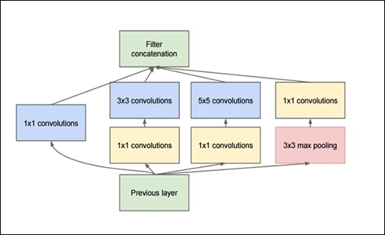

**Figure 6.1-** Architecture of Inception V3

1. **CODING**
   1. **Disease Detection**

* **DiseaseDetection_1**

This is a starting activity class in disease detection feature. It uses the layout file *activity_disease_detection1.xml.* We’ve used recycler view in layout. It shows the list of 6 plants and sets thumbnail image and plant name.

Here we created instance of our *MyAdapter* Class and set that object as an adapter to the recycler view.

* **MyAdapter**

This class extends RecyclerView.Adapter<MyAdapter.MyViewHolder>. It takes input from *DiseaseDetection_1.java* as plants name plants logo and description and inflates the recycler view. It also creates intent which lets user navigate to *DiseaseDetection_2.java* class.

* **DiseaseDetection_2**

This is a second activity class in disease detection feature. It uses the layout file *activity_disease_detection1.xml*. It provides an imageview and two buttons.

When user click on ‘Select’ button then device’s File Manager opens up and user need to select an image of diseased plant which he/she have chosen earlier. After selecting, the selected image is shown in the app.

Now when user click on ‘Start’ button plant name and selected image is passed to the *DiseaseDetection_3* activity.

* **DiseaseDetection_3**

This is a third activity class in disease detection feature. It uses the layout file *activity_disease_detection3.xml.* It shows the result of detected disease and steps to cure that disease. This class works as builder class for other classes named as *MLHelper* and *DiseaseDescHelper.* It takes the output result from both these classes and displays the final result to the user.

* **MLHelper**

This is main java class which feeds the image provided by the user to the actual ML model.

There are 6 ML models in our app in the *TFlite* format for each separate plant’s disease detection. They are stored under *ml* folder inside the app module named as follows:

1. **apple_model_unquant.tflite**
2. **corn_model_unquant.tflite**
3. **tomato_model_unquant.tflite**
4. **potato_model_unquant.tflite**
5. **grape_model_unquant.tflite**
6. **cherry_model_unquant.tflite**

This class takes plant name as input from *DiseaseDetection_3* class and initialise the respective plant’s ML model. It also takes the image provided by user and feeds that image to the initialised ML model.

When the model detects the disease in the image it returns the detected disease name of that plant. *MLHelper* forwards this disease name to the DiseaseDetection_3 class to display onto the screen.

* **DiseaseDescHelper**

This is a java class which is used to get the detected disease’s description. The *DiseaseDetection_3* class gets the detected disease name from *MLHelper* class and forwards that name to this class.

All information of descriptions of all diseases is stored under string-array in *strings.xml* file. This class finds the correct description of disease name from the string-array and returns the description to *DiseaseDetection_3* class.

* 1. **Weather Detection**
* **WeatherDetails**

This class is used to connect GUI with the backend. The data come from the API will pass to proper fields of GUI. The data comes in from API is min temperature, max temperature, sunrise, sunset, wind speed, wind pressure, humidity etc.

For this we use OpenWeathermap's Current Weather API this API provides the world’s most sophisticated weather intelligence. It provides forecast for every longitude and latitude point on Earth with Superior Accuracy.

Methods we used in this class are as follows:

1. onCreate() :- Called when the activity is created. Parameter of this method is Bundle savedInstanceState that is if the activity is being re-initialized after previously being shut down then this Bundle contains the data it most recently supplied in onSaveInstanceState.
2. onResume() :- This method gets called when the activity is in the resumed state. This method is called after onStart() method if the Activity has started or it can be called when the app is fully visible after paused state means after onPause() method.
3. showSettingsAlertPer() :- This function used show message to user to allow the location of their device.
4. getLocation() :- This function is used to tack the latitude and longitude of current location using getLatitude() and getLongitude().
5. onPreExecute() -: Invoked on the UI thread before the task is executed. This step is normally used to setup the task, for instance by showing a progress bar in the user interface.
6. doInBackground(Params...) :- invoked on the background thread immediately after onPreExecute() finishes executing. This step is used to perform background computation that can take a long time. The parameters of the asynchronous task are passed to this step. The result of the computation must be returned by this step and will be passed back to the last step. This step can also use publishProgress(Progress...) to publish one or more units of progress. These values are published on the UI thread, in the onProgressUpdate(Progress...) step.

* **WeatherGpsTracker**

This class is used to manage the location. It takes the location through the GPS and manage it properly. It helps the *weatherDetails* class.

Methods we used in this class are as follows:

1. LocationManager :- This class provides access to the system location services. These services allow applications to obtain periodic updates of the device's geographical location, or to be notified when the device enters the proximity of a given geographical location.
2. getLatitude() :- This method is used get the latitude of current location.
3. getLongitude() :- This method is used get the longitude of current location.
4. onLocationChanged() :- Called when the location has changed and locations are being delivered in batches. The default implementation calls through to onLocationChanged(android.location.Location) with all locations in the batch. The list of locations is always guaranteed to be non-empty, and is always guaranteed to be ordered from earliest location to latest location.
5. onProviderDisabled() :- Called when the provider this listener is registered with becomes disabled. If a provider is disabled when this listener is registered, this callback will be invoked immediately.
6. onBind() :- A bound service is an implementation of the Service class that allows other applications to bind to it and interact with it. To provide binding for a service, you must implement the onBind() callback method. This method returns an IBinder object that defines the programming interface that clients can use to interact with the service.

* **WeatherHttpHandler**

This class is used to request the API and manage the data which is come from the API.

1. makeServiceCall() – This method call http request to API using GET method.
2. convertStreamToString() – This method used to convert data into a string format.
   1. **Daily News**

* **NewsWorld**

This class is used to connect GUI with the backend. The data come from the API will pass to proper field of GUI. we use NewsAPI's News API has been the integral element allowing us to offer relevant and timely political news to our users – allowing them to take immediate action to contact their representatives using generated call scripts based on the articles they read. News API is a simple HTTP REST API for searching and retrieving live articles from all over the web.

1. getCategories() :- In our news application there are various news category so the data come from API is distributed according to their category using getCategories() method.
2. getNews() :- This method will request the API and get the news from the API.
3. onFailure() :- If sometime due to low connection of internet or some other purpose the data from API cannot access then this method display the error message
4. onCategoryCLick() :- This method is used to switch the user when he click according to the category.

* **NewsDeatilActivity**

When user click on the news then this class provide the news in detail. This class use to read the news in detail. When user click on the given news then the whole detail of news is provided.

* **NewsRVAdapter**

This class is used set the news according to title, image, and category in recycler view.

1. onCreateViewHolder() :- onCreateViewHolder only creates a new view holder when there are no existing view holders which the RecyclerView can reuse.
2. onBindViewHolder() - This method internally calls onBindViewHolder(ViewHolder, int) to update the RecyclerView.

* **CategoryRVAdapter**

This class is used to set the news according to their category.

* 1. **Market Price**
* **MarketPriceActivity**

This class is used to connect GUI with the backend. The data come from the API will pass to proper field of GUI. Here we use Open Government Data Platform of India's Daily price of commodities from various markets API This is the Open Government Data Portal designed, developed and hosted by the National Informatics Centre (NIC), a premier ICT organization of the Government of India under the aegis of the Ministry of Electronics & Information Technology.

The Objective of Open Government Data Platform India is to facilitate the access to Government owned shareable data and information in both human readable and machine readable forms in a proactive and periodically updatable manner, within the framework of various related policies, Acts and Rules of Government of India, thereby promoting wider accessibility and application of government owned data and unlocking the potential of data

1. loadData() – loadData is used to load and display the data.
2. onScrollStateChanged() - Callback method to be invoked when RecyclerView's scroll state changes.
3. onCreateOptionsMenu() - to create the options menu when the user opens the menu for the first time.

* **GoiDetail**

This class is used to take data like GroceryName, GroceryPlace, GroceryPrice, GroceryTime, etc. from the API and proper arrange it according to his proper place.

* **GoiAdapter**

This class is used to fetch the data come from API to the recycler view.

* **FilterActivity**

In market price option we add the feature that you can search the product data according to the state wise also destruct wise if you search the name of the state in a search option it will provide the product of that state or dissect. This class is for to filter the API data according to state and district wise.

* 1. **To Do List**

This module handles the to do list feature of our app. Task created by user is saved in local database SQLite. This module has various classes to do the following tasks:

1. Create a new task.
2. Save the created task in SQLite Database.
3. Retrieve the tasks saved in database and show in the application.
4. Modify existing tasks.
5. Delete existing tasks.
6. Change the status of tasks to complete or incomplete.
7. Handle user actions like swiping.
   1. **Fertilizer Calculator**

This module represents the Fertilizer Calculator feature of our application. This class takes input from user of land area and fertilizer values. This class has following methods:

1. makeCalculation_N()
2. makeCalculation_P()
3. makeCalculation_K()

These all methods calculates proportion of Nitrogen(N), Phosphorous(P) & Potassium(K) according to input land area and display into the application.

1. **IMPLEMENTATION**
   1. **Installation and Preparation**
2. Our application size is 49.24MB.
3. Our application runs on various android version.
4. Our application needs storage permission.
5. Our application needs location permission.
6. Our application needs internet.
7. One can use it by installing an .apk file of our project in the android smartphone.
   1. **Screenshots of the System**



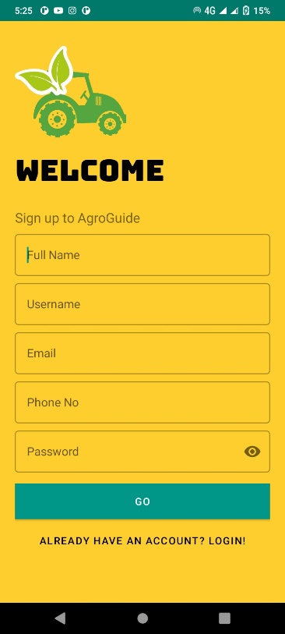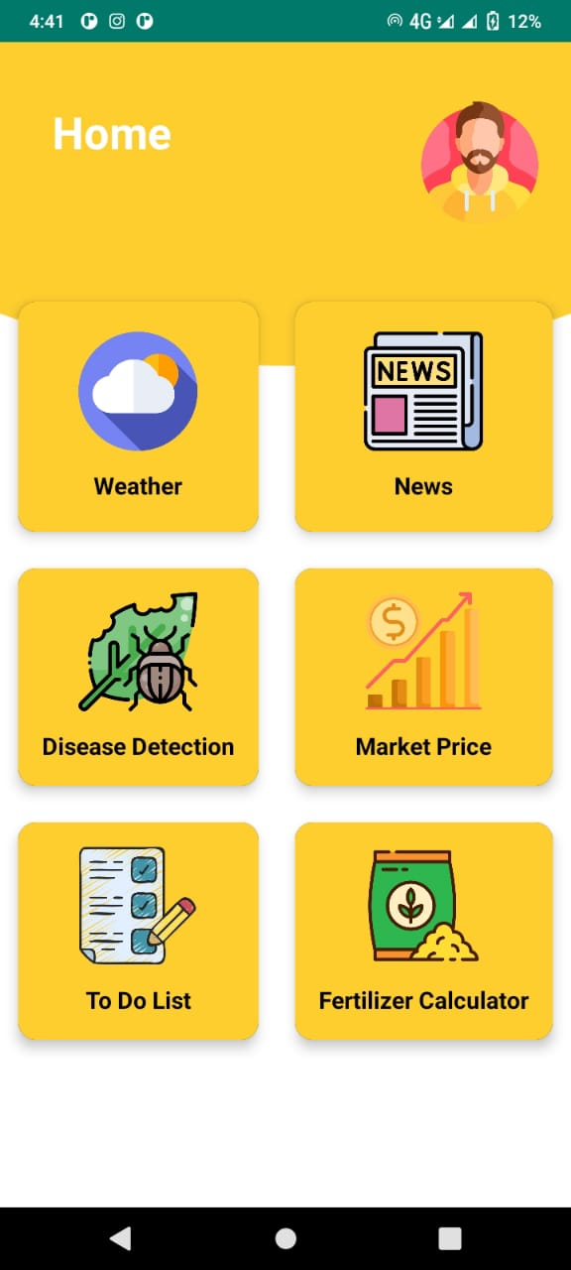

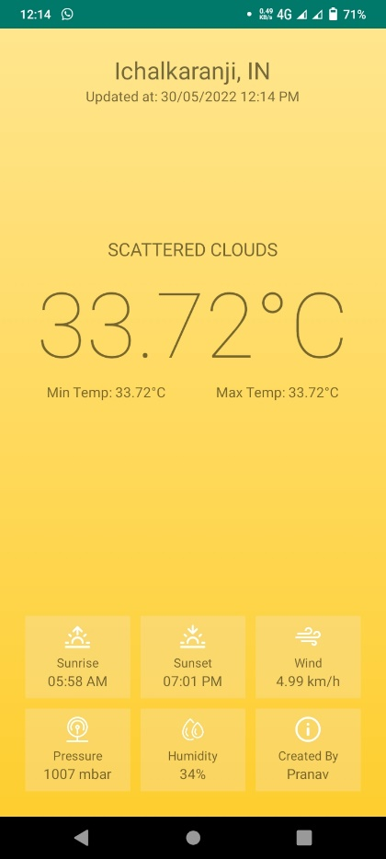 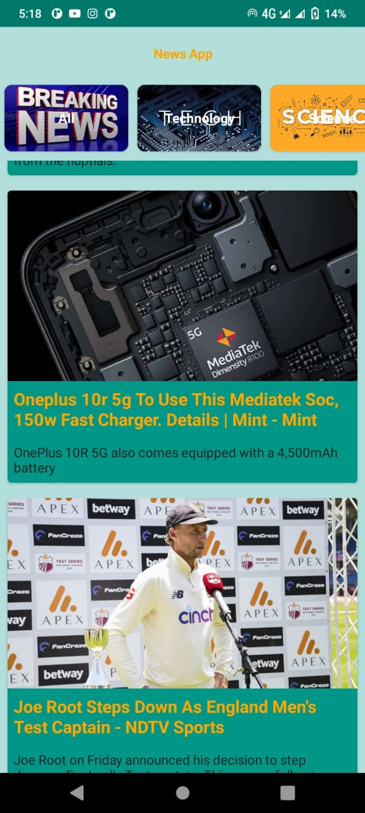

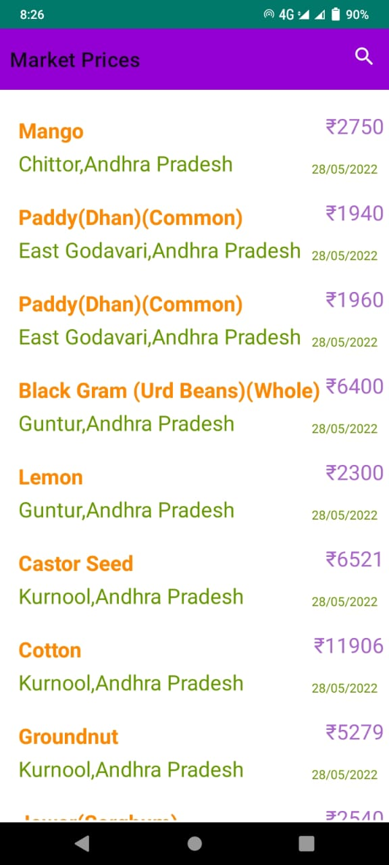 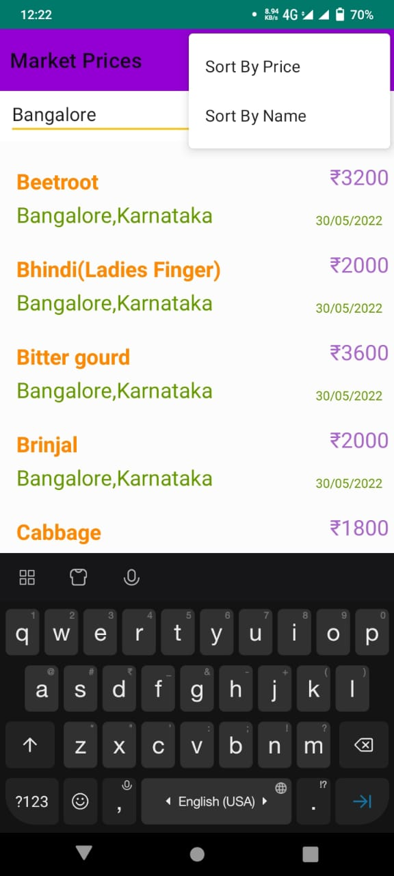

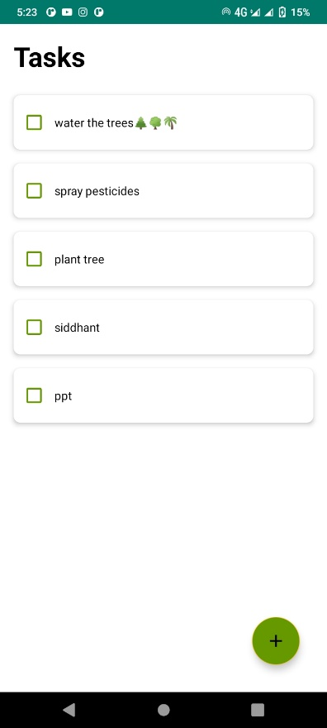 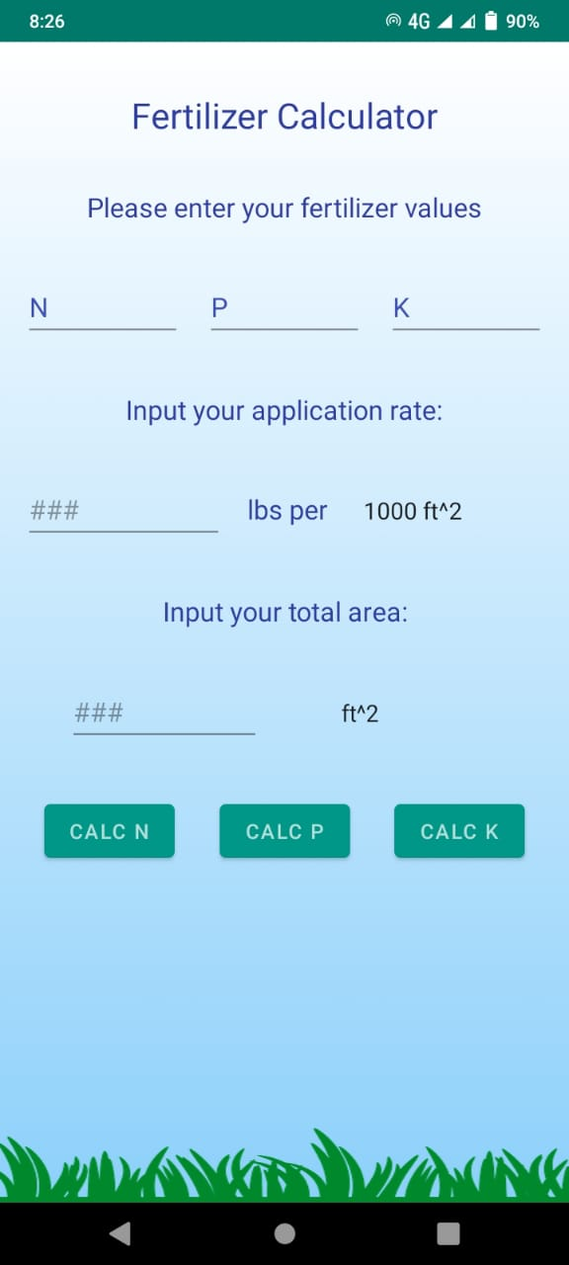

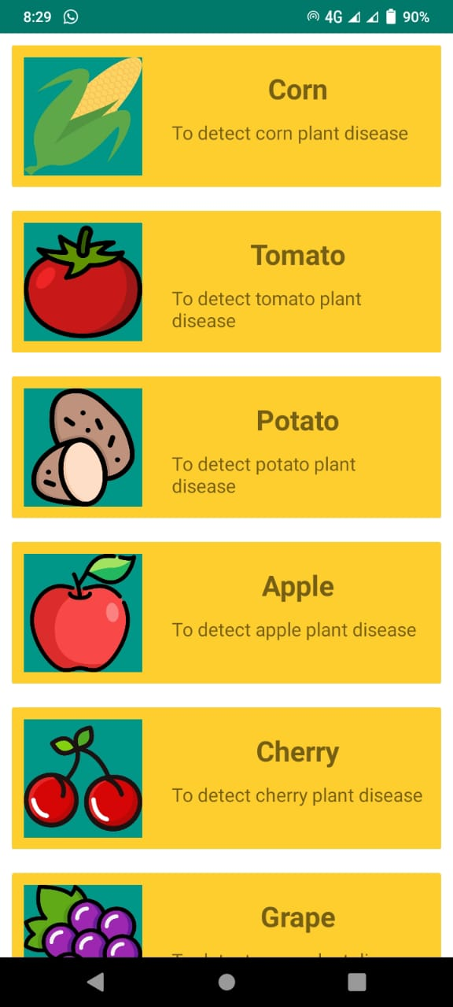 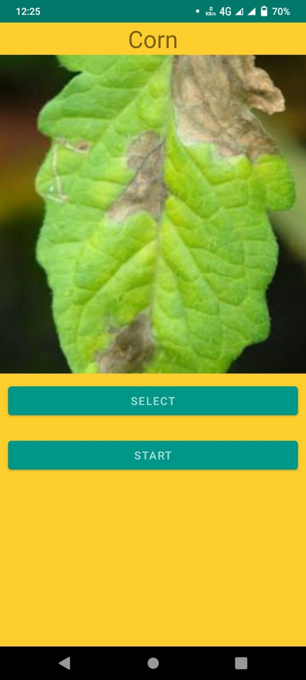

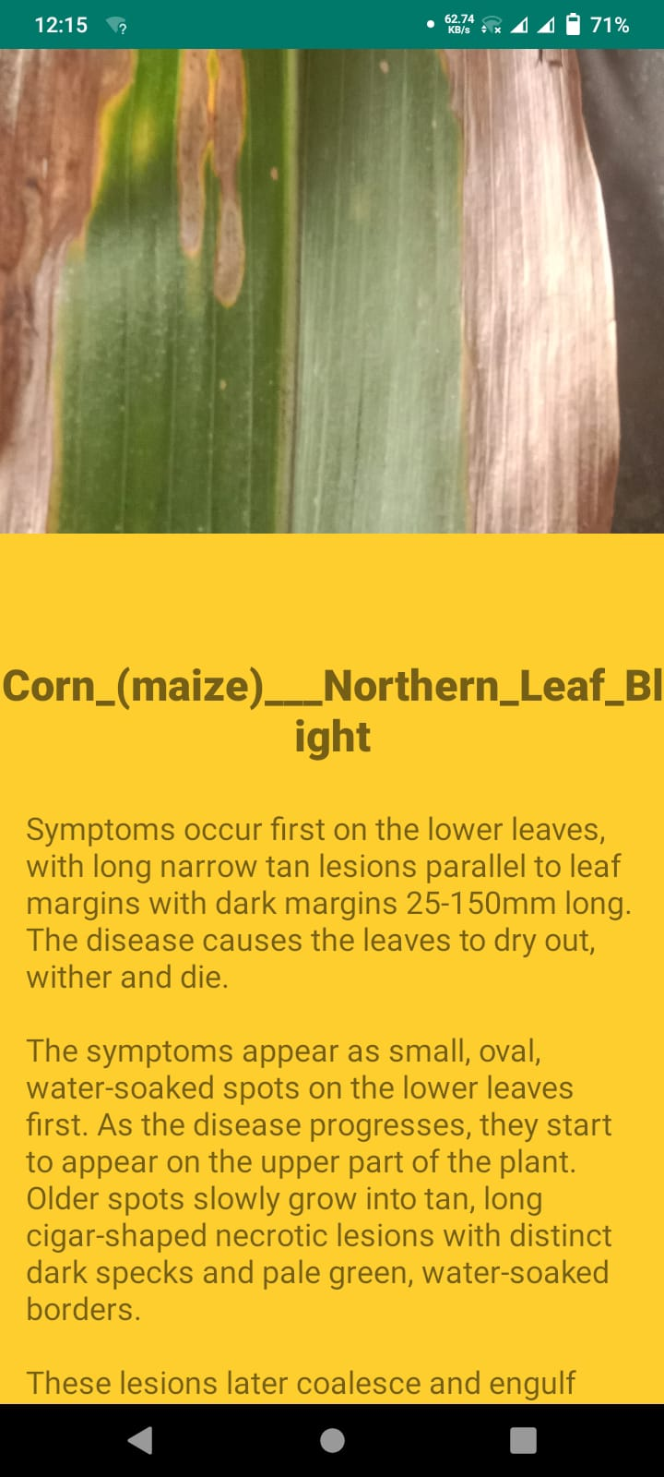 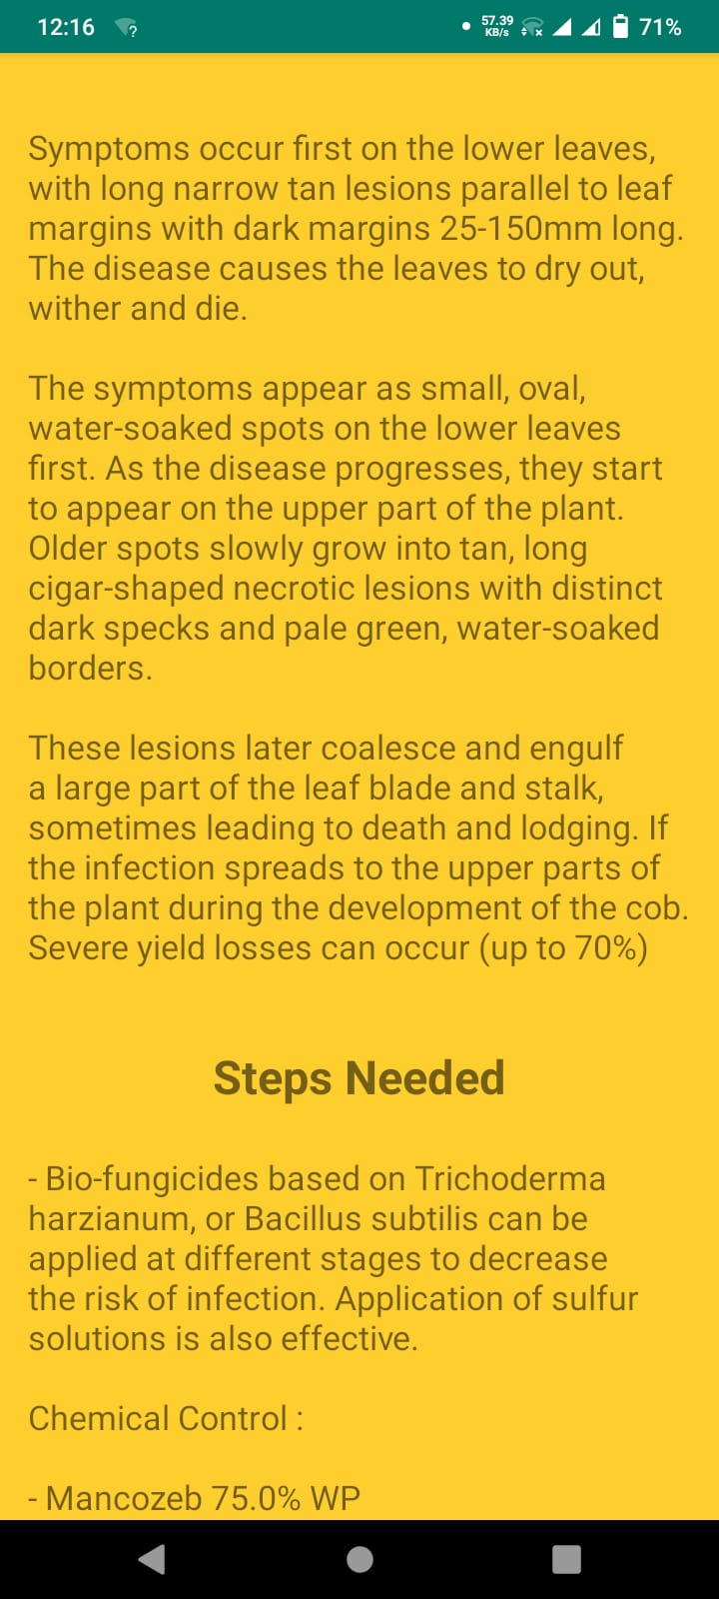

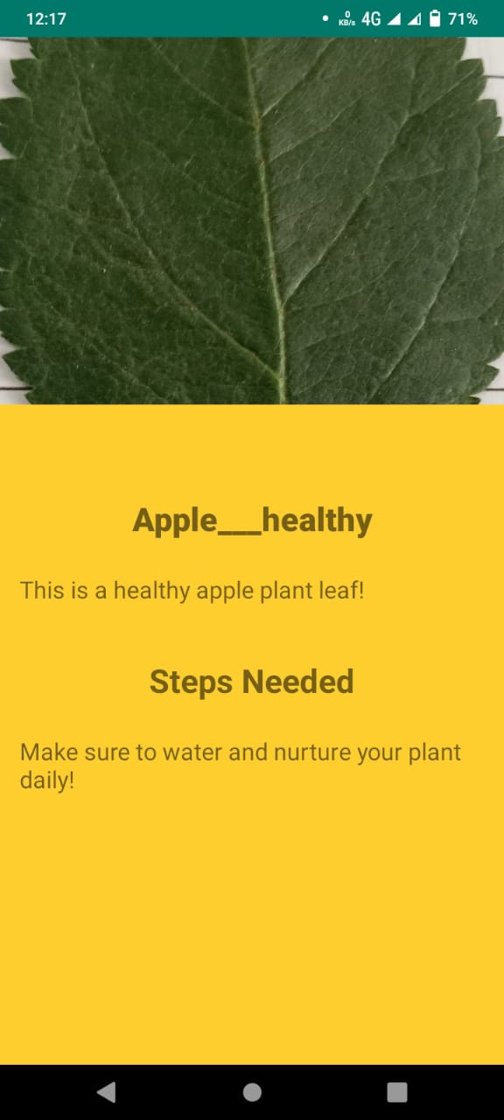 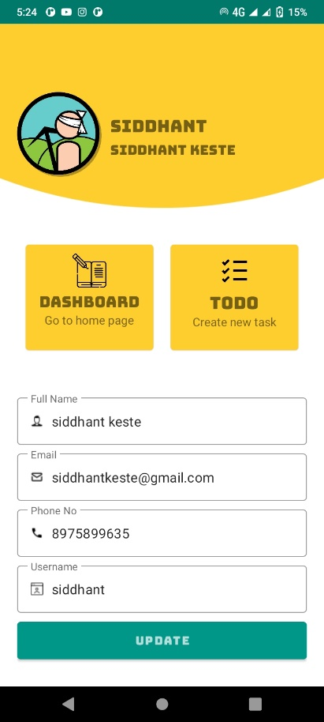

1. **SOFTWARE TESTING**
   1. **Introduction**

Software Testing is a method to check whether the actual software product matches expected requirements and to ensure that software product is Defect free. It involves execution of software/system components using manual or automated tools to evaluate one or more properties of interest. The purpose of software testing is to identify errors, gaps or missing requirements in contrast to actual requirements.

Some prefer saying Software testing definition as a White Box and Black Box Testing. In simple terms, Software Testing means the Verification of Application Under Test (AUT). This Software Testing course introduces testing software to the audience and justifies the importance of software testing.

* **Benefits of Software Testing :-**
* Cost-Effective: It is one of the important advantages of software testing. Testing any IT project on time helps you to save your money for the long term. In case if the bugs caught in the earlier stage of software testing, it costs less to fix.
* Security: It is the most vulnerable and sensitive benefit of software testing. People are looking for trusted products. It helps in removing risks and problems earlier.
* Product quality: It is an essential requirement of any software product. Testing ensures a quality product is delivered to customers.
* Customer Satisfaction: The main aim of any product is to give satisfaction to their customers. UI/UX Testing ensures the best user experience.
  1. **Types of Testing**

Following are the types of testing we’ve performed on our application:

* Black Box Testing

Black box testing involves testing against a system where the code and paths are invisible.

* End to End Testing

End to end testing is a technique that tests the application’s workflow from beginning to end to make sure everything functions as expected.

* Functional Testing

Functional testing checks an application, website, or system to ensure it’s doing exactly what it’s supposed to be doing.

* Interactive Testing

Also known as manual testing, interactive testing enables testers to create and facilitate manual tests for those who do not use automation and collect results from external tests.

* Integration Testing

Integration testing ensures that an entire, integrated system meets a set of requirements. It is performed in an integrated hardware and software environment to ensure that the entire system functions properly.

* Non-Functional Testing

Nonfunctional testing verifies the readiness of a system according to nonfunctional parameters (performance, accessibility, UX, etc.) which are never addressed by functional testing.

* Regression Testing

Regression testing is performed to determine if code modifications break an application or consume resources.

* Stress Testing

Stress testing is a software testing activity that tests beyond normal operational capacity to test the results.

* Unit Testing

Unit testing is the process of checking small pieces of code to ensure that the individual parts of a program work properly on their own, speeding up testing strategies and reducing wasted tests.

* White Box Testing

White box testing involves testing the product's underlying structure, architecture, and code to validate input-output flow and enhance design, usability, and security.

* 1. **Software Testing Life Cycle**

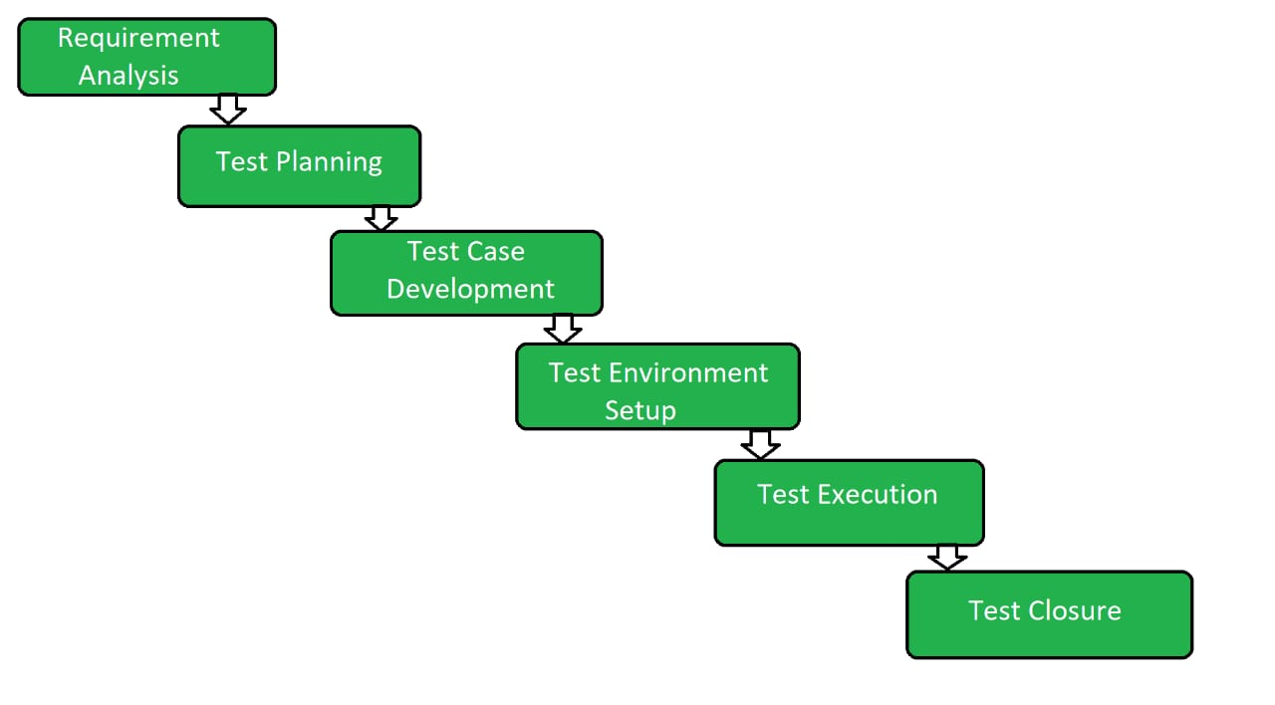

**Figure 7.1 -** Software Testing Life Cycle

* **Phases of STLC :**
* Requirement Analysis:

Requirement Analysis is the first step of Software Testing Life Cycle (STLC). In this phase quality assurance team understands the requirements like what is to be tested. If anything is missing or not understandable then quality assurance team meets with the stakeholders to better understand the detail knowledge of requirement.

* Test Planning:

Test Planning is most efficient phase of software testing life cycle where all testing plans are defined. In this phase manager of the testing team calculates estimated effort and cost for the testing work. This phase gets started once the requirement gathering phase is completed.

* Test Case Development:

The test case development phase gets started once the test planning phase is completed. In this phase testing team note down the detailed test cases. Testing team also prepare the required test data for the testing. When the test cases are prepared then they are reviewed by quality assurance team.

* Test Environment Setup:

Test environment setup is the vital part of the STLC. Basically test environment decides the conditions on which software is tested. This is independent activity and can be started along with test case development. In this process the testing team is not involved. either the developer or the customer creates the testing environment.

* Test Execution:

After the test case development and test environment setup test execution phase gets started. In this phase testing team start executing test cases based on prepared test cases in the earlier step.

* Test Closure:

This is the last stage of STLC in which the process of testing is analyzed.

* 1. **Test Cases**
* **Sign Up Page :**

|  |  |  |  |  |
| --- | --- | --- | --- | --- |
| **Test Case ID** | **Description** | **Expected Result** | **Actual Result** | **Status** |
| TC1 | FullName field left empty | Please enter full name | Please enter full name | PASS |
| TC2 | Username field left empty | Please enter username | Please enter username | PASS |
| TC3 | Email field left empty | Please enter email | Please enter email | PASS |
| TC4 | Phone No field left empty | Please enter Phone No | Please enter Phone No | PASS |
| TC5 | Password field left empty | Please enter password | Please enter password | PASS |
| TC6 | Username contains special charcters other than '_' | Username must not contain special characters | Username must not contain special characters | PASS |
| TC7 | Username starts with a digit | Username must start with an underscore or alphabet | Username must start with an underscore or alphabet | PASS |
| TC8 | Email does not end with '@gmail.com' | Invalid email | Invalid email | PASS |
| TC9 | PhoneNo does not contain 10 digits | Invalid phone no | Invalid phone no | PASS |
| TC10 | Password length shorter than 8 | Password too short | Password too short | PASS |
| TC11 | Password does not contain special characters or symbols | Password too weak | Password too weak | PASS |

**Table 4.1 –** Test cases for sign up page

* **Login Page :**

|  |  |  |  |  |
| --- | --- | --- | --- | --- |
| **Test Case ID** | **Description** | **Expected Result** | **Actual Result** | **Status** |
| TC1 | Correct Username entered and correct password | Login successfully | Login successfully | PASS |
| TC2 | Correct Username entered and wrong password | Wrong password | Wrong password | PASS |
| TC3 | Wrong Username  and correct password | Username does not exist | Username does not exist | PASS |
| TC4 | Wrong Username  and wrong password | Username does not exist | Username does not exist | PASS |

**Table 4.1 –** Test cases for login page

* **To Do List :**

|  |  |  |  |  |
| --- | --- | --- | --- | --- |
| **Test Case ID** | **Description** | **Expected Result** | **Actual Result** | **Status** |
| TC1 | New task entry left empty | Task content cannot be empty | Task content cannot be empty | PASS |
| TC2 | Task checkbox clicked | Task status gets updated in database | Task status gets updated in database | PASS |
| TC3 | Task fragment swiped right | Task edit option opened | Task edit option opened | PASS |
| TC4 | Task fragment swiped left | Task delete popup opened | Task edit popup opened | PASS |
| TC5 | Task deletion popup confirmed | Task entry deleted from database | Task entry deleted from database | PASS |
| TC6 | Tasks added and user restarts app | Task entries get retained | Task entries get retained | PASS |

**Table 4.1 –** Test cases for To Do List

1. **CONCLUSION**

Mobile apps are potential digital tools which can be effectively utilized to reach agricultural information to a large number of farmers within a short period of time. They can be used to enhance farm income and productivity through providing correct information, better input and farm management, easy marketing and linkage with government agency for policy support to farmer etc. In this whole project we make the app that makes the farmer life easy and increase his crop production and make him economically stronger. We build it using various modern technique. This app specially design to make farmer work easy.

Convolutional Neural Network is used to with a goal to detect the diseases in the crops. The model is basically tested on some types of plant species with some types of plant diseases. The model was made using Tensor flow frameworks and the system is implemented on Android. The overall system results show that the Mobile Net model works better as compared to the other models and provide better accuracy in detecting the diseases .As an extension to the project the number of classes of plants and its diseases will be increased . Also the model will be further improved by increasing the parameters for training and testing.

1. **REFERENCES & BIBLIOGRAPHY**
2. Santanu Phadikar and Jaya Sil “Rice Disease identification using Pattern Recognition Techniques” Proceedings of 11th International Conference on Computer and Information Technology (ICCIT 2008)25- 27 December, 2008, Khulna, Bangladesh, pp. 1-4244- 2136-7/08
3. Dheeb Al Bashish, Malik Braik and Sulieman BaniAhmad “A Framework for Detection and Classification of Plant Leaf and Stem Diseases” 2010 IEEE International Conference on Signal and Image Processing, pp. 978-1- 4244-8594-9/10
4. Zulkifli Bin Husin, Abdul Hallis Bin Abdul Aziz, Ali Yeon Bin Md Shakaff and Rohani Binti S Mohamed Farook “Feasibility Study on Plant Chili Disease Detection Using Image Processing Techniques” 2012 IEEE Third International Conference on Intelligent Systems Modelling and Simulation, pp. 978-0-7695-4668-1/12
5. Sabah Bashir and Navdeep Sharma “Remote Area Plant Disease Detection Using Image Processing” IOSR Journal of Electronics and Communication Engineering (IOSRJECE)ISSN : 2278-2834 Volume 2, Issue 6 (Sep-Oct 2012), PP 31-34
6. Murali Krishnan and Dr.M.G.Sumithra “A Novel Algorithm for Detecting Bacterial Leaf Scorch (BLS) of Shade Trees Using Image Processing” 2013 IEEE 11th Malaysia International Conference on Communications 26th - 28th November 2013, Kuala Lumpur, Malaysia pp. 978-1-4799-1532-3/13
7. Ms. Kiran R. Gavhale, Prof. Ujwalla Gawande and Mr. Kamal O. Hajari “Unhealthy Region of Citrus Leaf Detection Using Image Processing Techniques” 2014 IEEE International Conference for Convergence of Technology, pp. 978-1-4799-3759-2/14
8. Wan Mohd Fadzil W.M.N, Shah Rizam M.S.B and R. Jailani, Nooritawati M.T “Orchid Leaf Disease Detection using Border Segmentation Techniques” 2014 IEEE Conference on Systems, Process and Control (ICSPC 2014), 12 - 14 December 2014, Kuala Lumpur, Malaysia, pp. 978-1-4799-6106-1/14
9. Usama Mokhtar, Mona A. S. Alit, Aboul Ella Hassenian, Hesham Hefny “Tomato leaves diseases detection approach based on support vector machines” 2015 IEEE pp. 978-1-5090-0275-7/15
10. Sachin D. Khirade, A. B. Patil, “Plant Disease Detection Using Image Processing” 2015 IEEE International Conference on Computing Communication Control and Automation, pp. 978-1-4799-6892-3/15
11. Ghulam Mustafa Choudhary and Vikrant Gulati “Advance in Image Processing for Detection of Plant Diseases” International Journal of Advanced Research in Computer Science and Software Engineering 5(7), July- 2015, pp. 1090-1093 [ISSN: 2277 128X]
12. Ramakrishnan.M and Sahaya Anselin Nisha.A “Groundnut Leaf Disease Detection and Classification by using Back Probagation Algorithm” IEEE ICCSP 2015 conference, pp. 978-1-4 799-8081-9/15
13. Prakash M. Mainkar, Shreekant Ghorpade and Mayur Adawadkar “Plant Leaf Disease Detection and Classification Using Image Processing Techniques” International Journal of Innovative and Emerging Research in Engineering Volume 2, Issue 4, 2015, eISSN: 2394 – 3343, p-ISSN: 2394 – 5494
14. Prajakta Mitkal, Priyanka Pawar, Mira Nagane, Priyanka Bhosale, Mira Padwal and Priti Nagane “Leaf Disease Detection and Prevention Using Image processing using Matlab” International Journal of Recent Trends in Engineering & Research (IJRTER) Volume 02, Issue 02; February– 2016 [ISSN:2455-1457]
15. Savita N. Ghaiwat, ParulArora, “Detection and Classification of Plant Leaf Diseases Using Image processing Techniques: A Review”, International Journal of Recent Advances in Engineering and Technology, ISSN: 2347-2812, Volume 2, Issue 3, 2014
16. Prof. Sanjay B. Dhaygude and Mr. Nitin P. Kumbhar, “Agricultural plant Leaf Disease Detection Using Image Processing” International Journal of Advanced Research in Electrical, Electronics and Instrumentation Engineering, Volume 2, Issue , 2013
17. Mr. Pramod and S. landge , “Automatic Detection and Classification of Plant Disease through Image Processing”, International Journal of Advanced Research in Computer Science and Software Engineering, Volume 3, Issue 7, ISSN: 2277 128X, 2013
18. Anand H. Kulkarni and Ashwin Patil R. K, “Applying image processing technique to detect plant diseases”, International Journal of Modern Engineering Research (IJMER), Volume 2, Issue.5, pp-3661-3664 ISSN: 2249- 6645, 2012
19. Haiguang Wang, Guanlin Li, Zhanhong Ma, Xiaolong Li, “Image Recognition of Plant Diseases Based on Back propagation Networks”, 5th International Congress on Image and Signal Processing (CISP), 2012
20. Piyush Chaudhary Anand K. Chaudhari, Dr. A. N. Cheeranand Sharda Godara “Color Transform Based Approach for Disease Spot Detection on Plant Leaf”, International Journal of Computer Science and Telecommunications, Volume 3, Issue 6, 2012
21. M. Egmont-Petersen, “ Image processing with neural networks”, Elsevier, Volume 35, Issue 10, October 2002, Pages 2279–2301 2002
22. Muhammad Faisal Zafar, Dzulkifli Mohamad, Muhammad Masood Anwar “Recognition of Online Isolated Handwritten Characters by Back propagation Neural Nets Using Sub-Character Primitive Features”, IEEE Multitopic Conference, 2006
23. Jayme Garcia, ArnalBarbedo, “Digital image processing techniques for detecting, quantifying and classifying plant diseases”, Springer Plus, 2013